Request for Proposal #RFP-26-007
For
Northeast Substation LED Wall Display

Opening Date & Time: Wednesday, February 18, 2025 at 11:00 a.m.

Mandatory Requirements:

• Signed Cover Sheet from this Solicitation
• Contractor Information Form
• Proprietary / Confidential Statement
• Exhibit 1 – Exception Form
• Exhibit 2 – Lobbying Certification

• Exhibit 3 – Non-Collusion Affidavit
• Exhibit 4 – Minimum Insurance Requirements
• Addendum(s) Acknowledgement
• Fee Schedule

Contractor Name | Signed | Addendum (2) | Requirements Met
AVI SPL LLC | Yes | Yes | Yes
CCS Presentation Systems | Yes | Yes | Yes
Global Technology Group | Yes | Yes | Yes
High Country Low Voltage LLC | Yes | Yes | Yes
Impression AV | Yes | No | No
Security 101 | Yes | Yes | Yes

Public Opening: Yes

Verified and Acknowledged for completeness and accuracy:
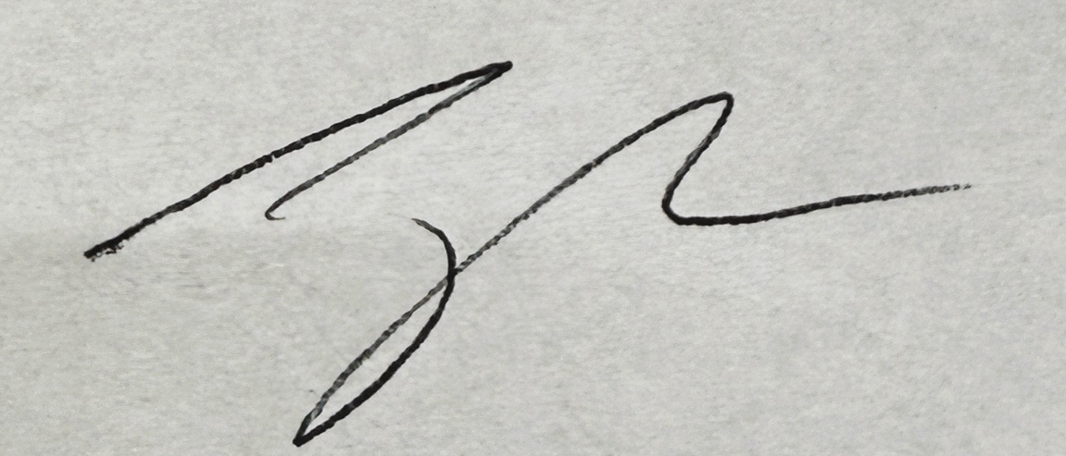 02/18/2026

Jake Harper, Associate Procurement Specialist Date
El Paso County, Colorado – Contracts and Procurement Division

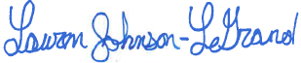 2/18/2026

Lauren Johnson-LeGrand, Administrative Specialist Date
El Paso County, Colorado – Contracts and Procurement Division

