Request for Proposal #RFP-26-030
For
Professional Auditing Services

Opening Date & Time: Wednesday, May 13, 2026 at 2:30 p.m.

Mandatory Requirements:

- Signed Cover Sheet from this Solicitation
- Consultant Information Form
- Proprietary / Confidential Statement
- Submission Form
- Exhibit 1 – Exception Form
- Exhibit 2 – Lobbying Certification
- Exhibit 3 – Non-Collusion Affidavit
- Exhibit 4 – Minimum Insurance Requirements
- Addendum(s) Acknowledgement
- Subcontractor List (if applicable)
- Technical
- Pricing Proposal
- Proof of Required Licenses and Certificates
- Certificate of Good Standing
- Submission Form
- W-9 Documentation

Vendor Name | Signed | Addendum (1) | Requirements Met
Barnhart | Yes | Yes | Yes

Public Opening: Yes

Verified and Acknowledged for completeness and accuracy:

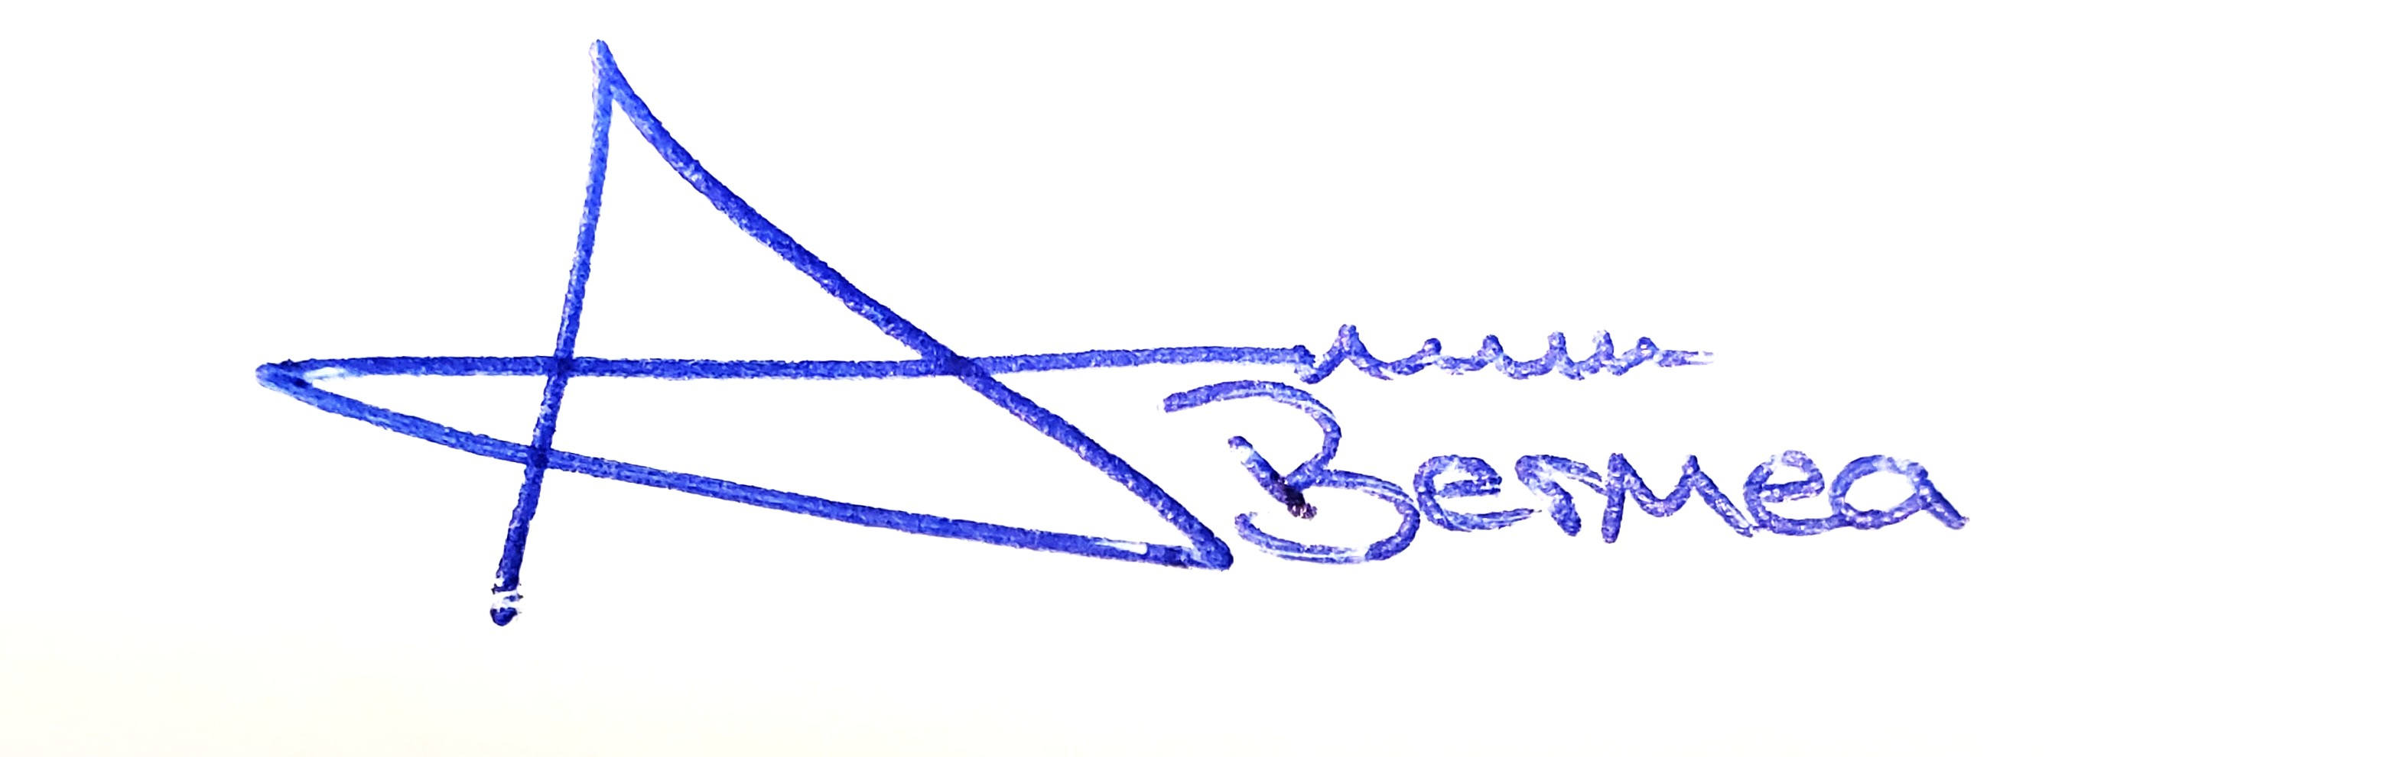 05/14/2026

Arron Bermea, Associate Procurement Specialist Date
El Paso County, Colorado – Contracts and Procurement Division

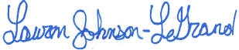 5/14/2026

Lauren Johnson-LeGrand, Administrative Specialist Date
El Paso County, Colorado – Contracts and Procurement Division

