El Paso County
Contracts and Procurement Division
15 East Vermijo Avenue
Colorado Springs, Colorado 80903
REQUEST FOR PROPOSAL RFP #26-028
Addendum #1 – April 8, 2026


THIS ADDENDUM SHALL BECOME A PART OF THE SOLICITATION
AND MUST BE ACKNOWLEDGED

Request for Proposal RFP-26-028 - Citizens Service Center (CSC) Carpet Replacement - dated March 23, 2026

CLARIFICATIONS:

Please use the attached Pricing Form to submit current industry standard pricing for RFP-26-026.

El Paso County will only accept electronic bid proposals submitted through the Rocky Mountain E-Purchasing system. A Submittal Log will be posted after the County has had an opportunity to review and verify the submittals offered to the County.

The original Offer must be received before the due date and time through an electronic package transmitted through the Rocky Mountain E-Purchasing system. The Vendor is responsible for ensuring its Response is posted in its entirety by the due date and time outlined in the solicitation document. No allowances will be provided to those Vendors whose submittal is not uploaded prior to the due date and time outlined in the solicitation.

If the submittal arrives late and/or is not uploaded in its entirety, it will not be included in the electronic lockbox.

ADMINISTRATION:

- The question period has expired
- Responses should follow the Response Format on pages 8-9 and include all responses to all mandatory requirements.
- We will be verifying submittals include the following:
- Submittal properly acknowledged (Cover Sheet)
- Addendum acknowledged
  - Required Documentation
    - Contractor Information Form
    - Proprietary / Confidential Statement
    - Signed copies of any addenda issued regarding this Solicitation
    - Exhibit 1, 2, 3, 4
    - Work Plan and Schedule
    - Contractor Information Form
- Evaluation Criteria Documentation
- Submission Form

If a submittal is missing any of the above-mentioned documentation the submittal may be returned to the vendor as non-responsive and be deemed ineligible to participate.

RESPONSE TO QUESTIONS:

- Q1-Will the CSC Employees be working?

  - A1 - Employees will continue working during the project; however, the carpet replacement will be completed in phases, one section at a time. While employees may be present in areas adjacent to the work, they will not remain in the specific sections undergoing carpet replacement. Those areas will be cleared of all personal belongings, and employees assigned to those sections will be temporarily relocated to a separate location while work is in progress.

- Q2-Will alternates be accepted or considered?

  - A2 - Alternates will be considered only if the proposed materials are equal to or superior to the specified materials.

- Q3-What are the planned work hours? Can nights and weekends be allowed?

  - A3 - Planned work hours will be from 7:00 a.m. to 7:00 p.m. MST. Work outside of these hours, including nights and weekends, may be permitted if coordinated in advance with the project manager.

- Q4-What is the background check process, and the costs associated?

  - A4 - The background check form is attached. Additional instructions will be provided once the project has been awarded. The cost is $6 per person, payable in exact cash.

- Q5-Where is the storage area for the daily work?

  - A5 - A designated storage area is available near the loading bay for larger quantities of materials. For smaller, day-to-day materials, locations on each floor will be coordinated and provided to allow for easier access.

- Q6-Are there any additional drawings?

  - A6 - Additional drawings will be made available once the project has been awarded.

- Q7-Will we be allowed to have a roll off on the premises?

  - A7 - Space for a roll-off can be coordinated through the project manager, with a designated location available at the back of the building.

- Q8-Who will do the electrical hookups and unhooking?

  - A8 - All electrical hookups and disconnections will be coordinated and performed by a licensed electrician.

- Q9-Who will take care of the Computers and Copiers?

  - A9 - The El Paso County IT Department will be responsible for disconnecting all computers and copiers.

- Q10-Who will be moving the Cubical walls, Desks and chairs or any furniture?

  - A10 - The vendor will be responsible for moving all cubicle walls, desks, chairs, and other furniture.

- Q11-Where will our employees be able to enter and exit?

  - A11 - Employees will receive ID cards that provide access to the back lot as well as all building entrances.

- Q12-The proposal states the following; however, we are submitting electronically, please advise as we
will be unable to keep the pricing separate from the rest of the proposal.
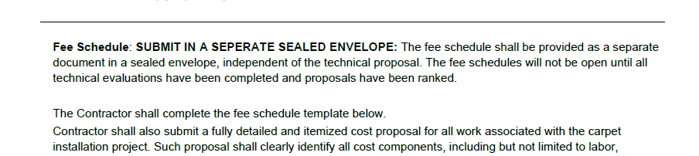

  - A12 - The evaluation process is a twostep process. First part being the technical review to be submitted in the first envelope, the second step is the pricing review to be submitted in the second envelope. Suggestion is if your phase one technical review (envelope 1) is going to contain pricing information blackout that particular page, then resubmit the pricing information into the pricing phase two (envelope 2). Otherwise, you may be disqualified.
.
- Q13-BID Bond and Performance Details?

  - A13 – A 5% Bid Bond is required at the time of Bid submission. A 100% Performance Bond is required at the time of contract signing.

Signature below indicates that applicant has read all the information provided above and agrees to comply in full. This addendum is considered as a section of the Request for Proposal and therefore, this signed document shall become considered and fully submitted with the original package.

PRINT OR TYPE YOUR INFORMATION

Company Name | Fax
Address: | City/State/Zip:
Contact Person: | Title:
Email: | Phone:
Authorized Representative’s Signature: |  | Date:
Printed Name: | Title:
Email: | Phone:

