Request for Proposal #RFP-26-017
For
Traffic Sign-Posts, Parts, Hardware, and Brackets

Opening Date & Time: Wednesday April 7, 2026 at 2:30 p.m.

Mandatory Requirements:
- Cover Sheet
- Vendor Information Form
- Proprietary/Confidential Statement

- Exhibits 1-4
- Addendum Acknowledged
- Pricing Form
- Evaluation Criteria Documentation

Vendor Name | Signed | Addendum (1) | Requirements Met
J&A Traffic Products | Yes | Yes | Yes
MD Solutions | Yes | Yes | Yes
Road Side Supplies LLC | Yes | Yes | Yes

Public Opening: Yes

Verified and acknowledged for completeness and accuracy:

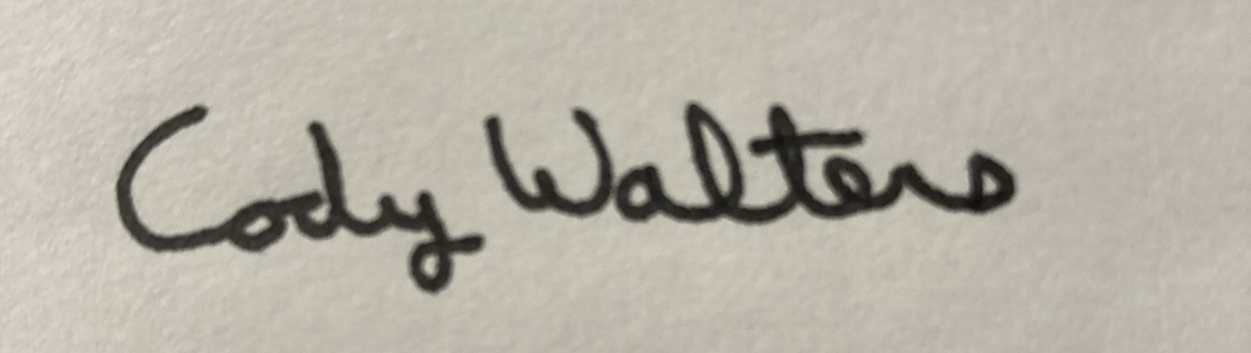 4/8/2026

Cody Walters, CPPB, Procurement Specialist Date
El Paso County, Colorado – Contracts and Procurement Division

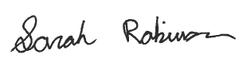 4/8/2026

Sarah Robinson, Administrative Coordinator Date
El Paso County, Colorado – Contracts and Procurement Division

