FINAL AWARD NOTIFICATION

RFP-26-016
Meridian Road and Flower Road Intersection Improvements

Term of Agreement: Four Years and Two Months

Initial Contract Term: May 18, 2026 to July 31, 2030

Piggyback Contract: Yes

PURCHASE BY OTHER GOVERNMENTAL AGENCIES: Each governmental unit which avails itself of this Solicitation will establish its own contact, place its own orders, issue its own purchase orders, be invoiced there from, and make its own payments and issue its own exemption certifications as required by the Vendor. It is understood and agreed that El Paso County is not a legally binding party to any contractual agreement made between any other governmental unit and the Vendor as a result of this Solicitation.

Awarded To: Kimley-Horn and Associates, Inc.
Adam Gomez, PE
2 North Nevada Avenue, Suite 900
Colorado Springs, CO 80903

Adam.gomez@kimley-horn.com
719-647-7930

Procurement Contact: Matthew Marter, CPPB
Senior Procurement Specialist
MatthewMarter@elpasoco.com
719-520-6663

Approved By:
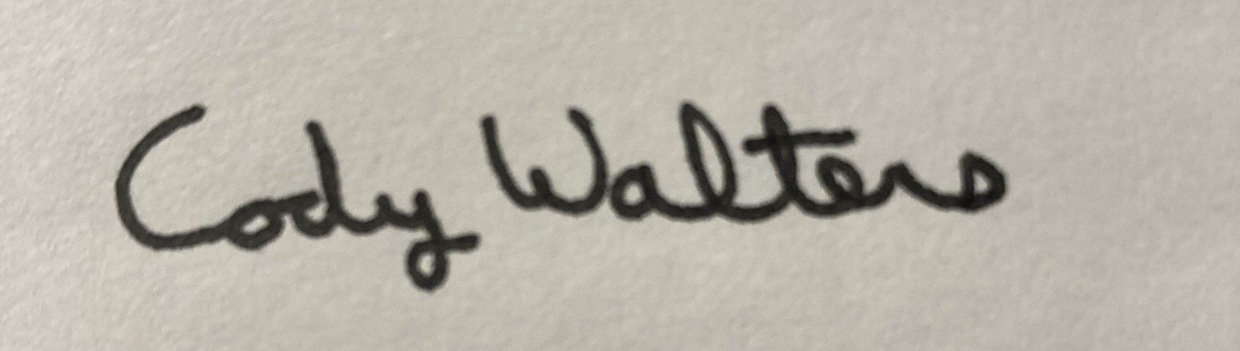 5/20/2026
_____________________________________________ _____________________
Cody Walters, CPPB, Procurement Specialist Date

