March 25, 2026

John Buchanan
Finsterwald Services
1680 S 21st Street
Colorado Springs, CO 80904
jbuchanan@finsterwaldservices.com

Dear Mr. Buchanan,

Thank you for your interest in providing El Paso County with the Construction of the El Paso County Pedestrian Crossings Improvements Project – Construction Package #3.

Based on El Paso County’s assessment of your submittal in response to our Invitation for Bid, your firm has been selected to negotiate a contract with El Paso County, Colorado.

We will be in contact with your firm within the next few weeks to begin the process of negotiating a contract and the establishment of an operations plan for the Construction of the El Paso County Pedestrian Crossings Improvements Project – Construction Package #3.

In addition, you are requested to furnish within two (2) weeks of receipt of this letter, Certificates of Insurance evidencing compliance with El Paso County’s requirements for insurance and a copy of your current proof of registration with State of Colorado.

We appreciate your interest in doing business with El Paso County and encourage you to continue to apply for future opportunities.

Sincerely,

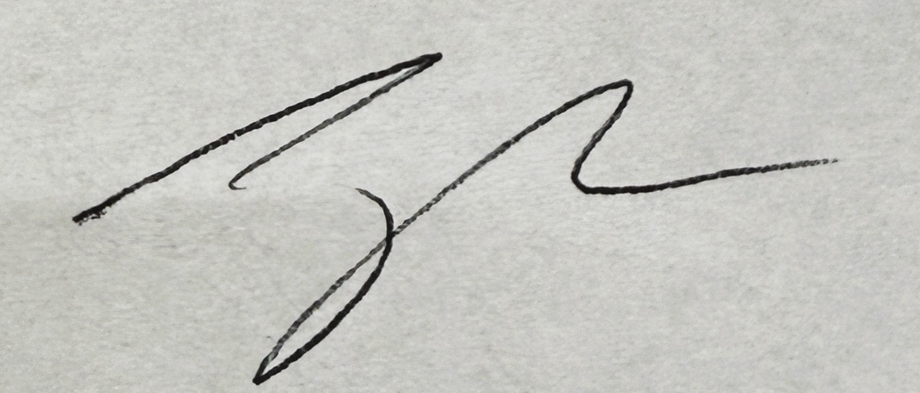

Jake Harper, CPPB
Associate Procurement Specialist
JakeHarper@elpasoco.com
719-520-6857

