Invitation for Bid #IFB-26-015
For
Construction of the El Paso County Pedestrian Crossing Improvements – Package #3

Opening Date & Time: Wednesday, March 11, 2026 at 1:00 p.m.

Mandatory Requirements:
- Cover Sheet
- Contractor Information Form
- Proprietary / Confidential Statement
- Sub-contractor List, if applicable
- Exhibits 1 - 6
- Proof of SAM.gov Eligibility
- CDOT Forms 606, 1413, 1414
- Work Plan and Schedule
- Addendum(s) Acknowledged
- Bid bond 5%
- Bid Form

Contractor Name | Signed | Addendum (2) | Requirements Met | Cost
Blue Ridge Construction Inc | Yes | Yes | No | $3,344,569.25
Finsterwald Service | Yes | Yes | Yes | $3,351,918.70
Maher Construction | Yes | Yes | Yes | $3,832,497.15

Public Opening: Yes

Verified and Acknowledged for completeness and accuracy:

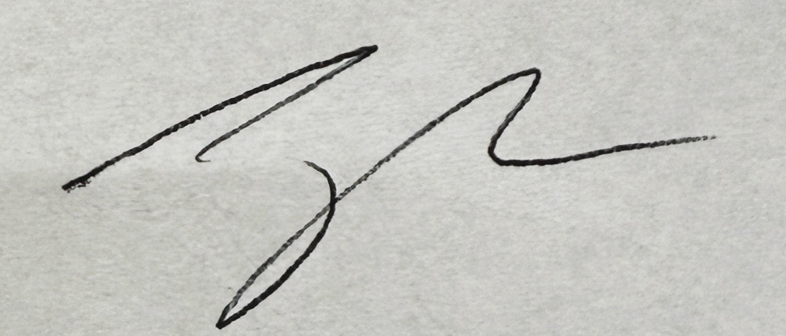 3/11/2026

Jake Harper, Associate Procurement Specialist Date
El Paso County, Colorado – Contracts and Procurement Division

 3/11/2026

Lauren Johnson-LeGrand, Administrative Specialist Date
El Paso County, Colorado – Contracts and Procurement Division

