Invitation for Bid #IFB-26-014
For
Construction of the El Paso County Pedestrian Crossing Improvements – Construction Package #2 Project

Opening Date & Time: Thursday, March 10, 2016 at 2:00 p.m.

Mandatory Requirements:
- Cover Sheet
- Addendums 1 & 2 Acknowledged
- Contractor Information Form
- Proprietary/Confidential Statement
- Exhibits 1-6
- Proof of Sam.gov eligibility
- Work Plan and Schedule
- Bid Form
- Bid Bond
- CDOT Forms 606 & 1413

Vendor Name | Signed | Addendum (1&2) | Requirements Met | Cost
Morton Electric, Inc. | Yes | Yes | Yes | $1,914,413.00
Native Sun Construction | Yes | Yes | Yes | $1,882,281.83
West Fork Construction | Yes | Yes | Yes | $1,920,520.00

Public Opening: Yes

Verified and Acknowledged for completeness and accuracy:

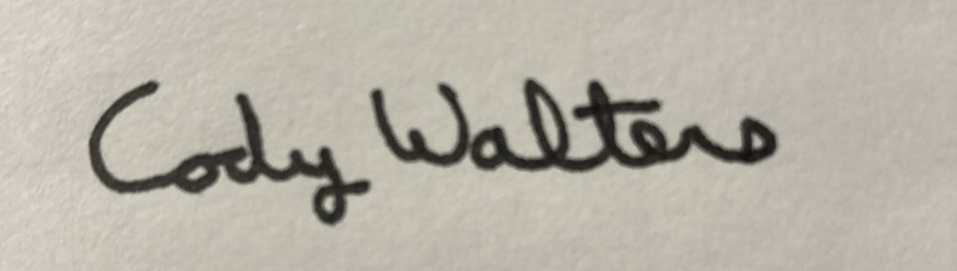 4/30/2026

Cody Walters, CPPB, Procurement Specialist Date
El Paso County, Colorado – Contracts and Procurement Division

 4/30/2026
Lauren Johnson-LeGrand, Administrative Specialist Date
El Paso County, Colorado – Contracts and Procurement Division

