FINAL AWARD NOTIFICATION

IFB-26-014
El Paso County Pedestrian Crossing Improvements – Construction Package #2 Project

Contract Term: May 26, 2026 thru December 11, 2026

Piggyback Contract: Yes

PURCHASE BY OTHER GOVERNMENTAL AGENCIES: Each governmental unit which avails itself of this Solicitation will establish its own contact, place its own orders, issue its own purchase orders, be invoiced there from, and make its own payments and issue its own exemption certifications as required by the Vendor. It is understood and agreed that El Paso County is not a legally binding party to any contractual agreement made between any other governmental unit and the Vendor as a result of this Solicitation.

Awarded To: Native Sun Construction
Fredericksun Barlow - Estimator
15020 Woodcarver Dr
Monument, CO 80132

Fredericksun.barlow@nscteam.com
719-413-4685

Procurement Contact: Cody Walters, CPPB
Procurement Specialist
CodyWalters@elpasoco.com
719-520-6593

Approved By:

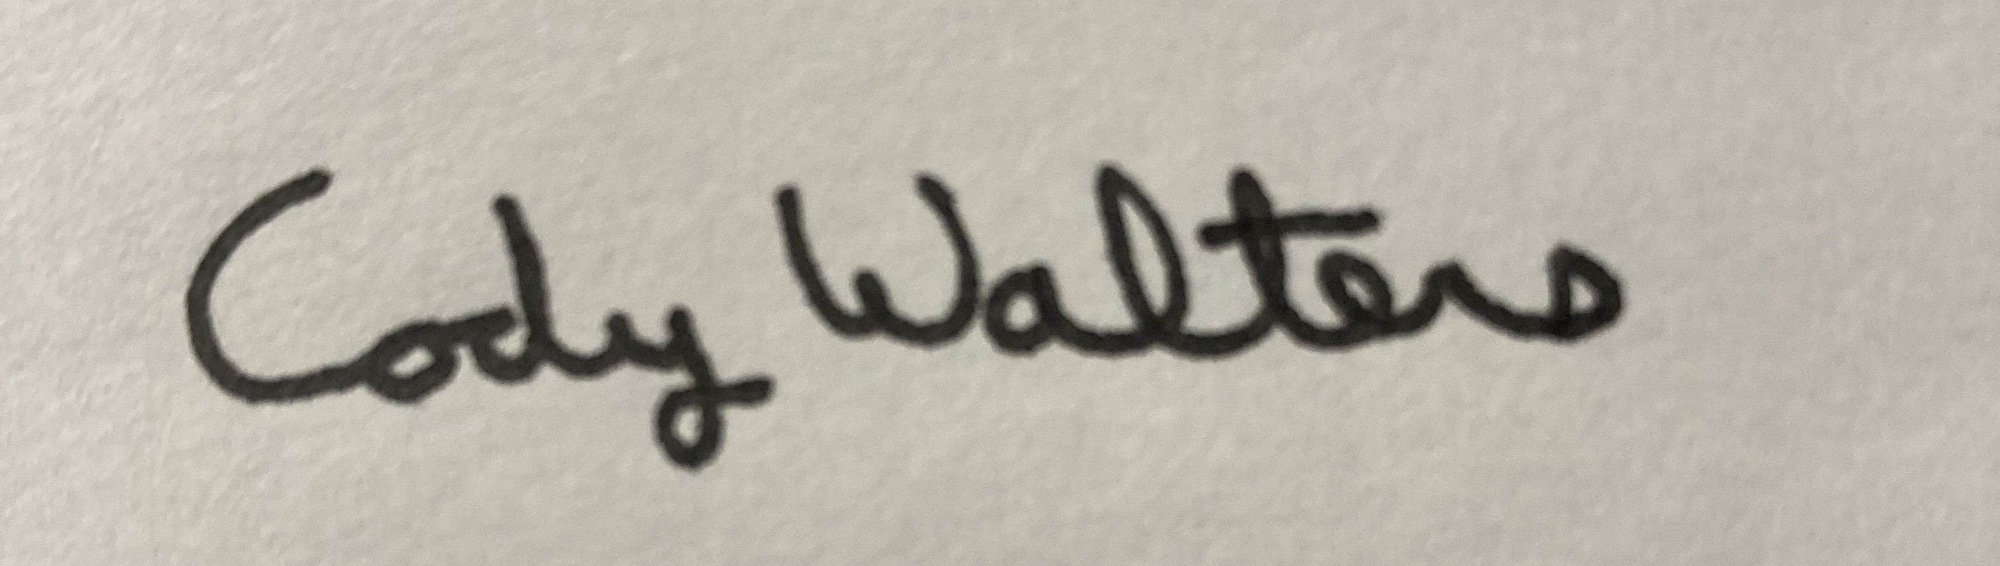 5/27/2026
________________________________________________________ _____________________
Cody Walters, CPPB, Procurement Specialist Date

