April 13, 2026

Attn: Nim Patel, Chief Operating Officer
Colorado Enterprise Fund
1888 N Sherman St - Suite 530,
Denver, CO 80203
nim@coloradoenterprisefund.org

Dear Mr. Patel,

Thank you for your interest in providing El Paso County with Business Loan Fund Administration and Management Services.

Based on El Paso County’s assessment of your submittal in response to our Request for Proposal, your firm has been selected to negotiate a contract with El Paso County, Colorado.

We will be in contact with your firm within the next few weeks to begin the process of negotiating a contract for Business Loan Fund Administration and Management Services.

In addition, you are requested to furnish within two (2) weeks of receipt of this letter, Certificates of Insurance evidencing compliance with El Paso County’s requirements for insurance and a copy of your current proof of registration with State of Colorado.

We appreciate your interest in doing business with El Paso County and encourage you to continue to apply for future opportunities.

Sincerely,

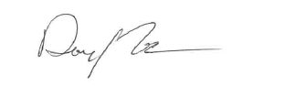

Danny Tesh
Associate Procurement Specialist
DannyTesh@elpasoco.com
719-520-6772

