Request for Proposal #RFP-26-003
For
Vollmer Road and Burgess Road Intersection Improvement Project

Opening Date & Time: Wednesday January 14, 2026 at :1:00 p.m.

Mandatory Requirements:
- Cover Sheet
- Consultant Information Form
- Proprietary/Confidential Statement

- Exhibits 1-4
- Addendum Acknowledged
- Fee Schedule
- Evaluation Criteria Documentation
- Work Plan and Schedule

Vendor Name | Signed | Addendum (1) | Requirements Met
Horrocks | Yes | Yes | Yes
Kimley-Horn and Associates, Inc | Yes | Yes | Yes
Mead and Hunt, Inc | Yes | Yes | Yes
Olsson | Yes | Yes | Yes
Stanley Consultants, Inc | Yes | Yes | Yes

Public Opening: Yes

Verified and acknowledged for completeness and accuracy:
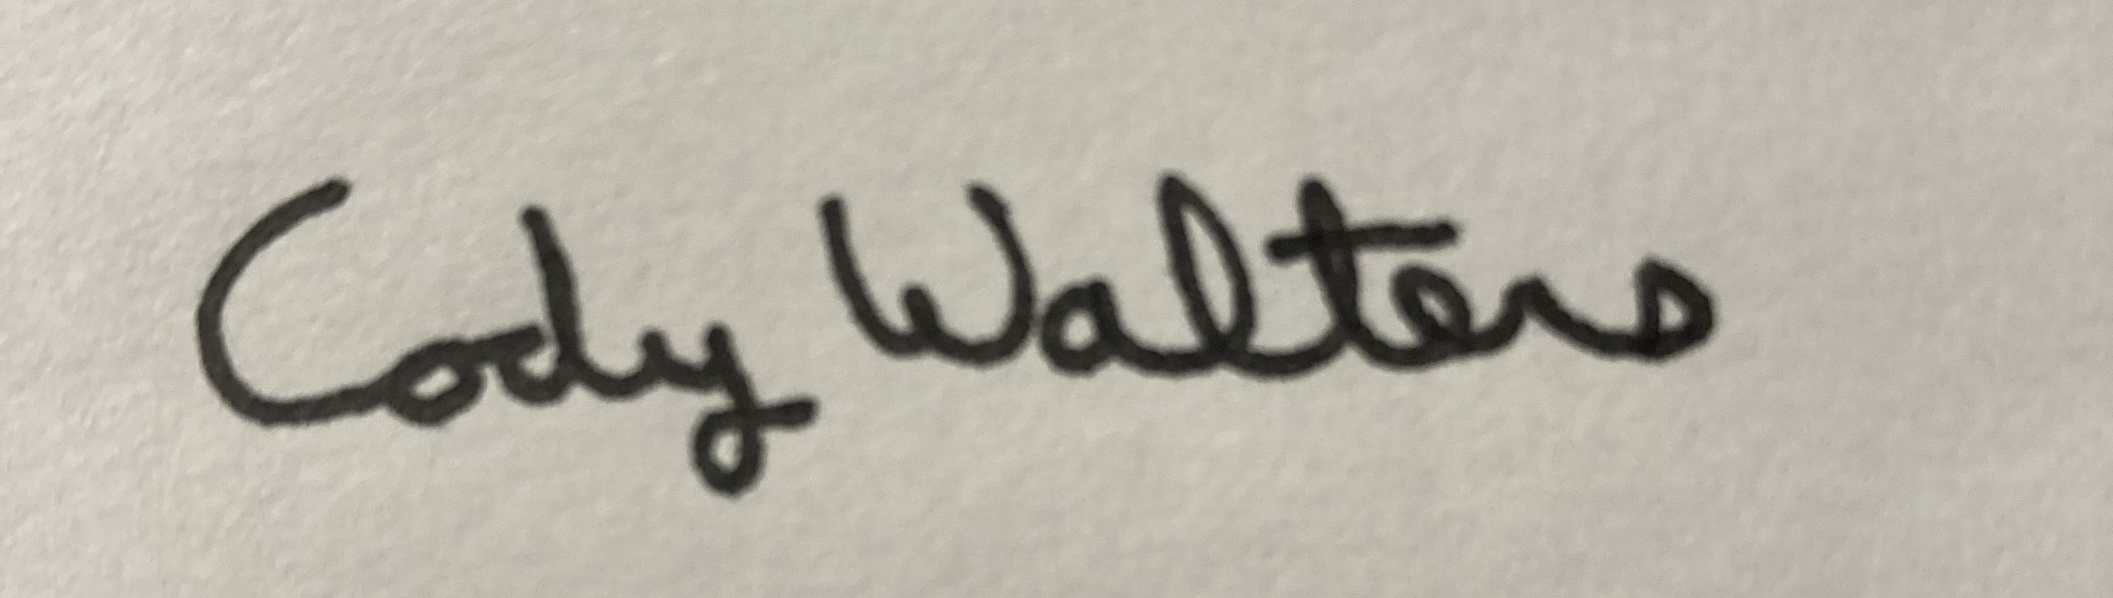 1/14/2026

Cody Walters, CPPB, Associate Procurement Specialist Date
El Paso County, Colorado – Contracts and Procurement Division

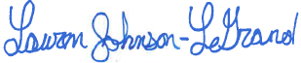 1/14/2026

Lauren Johnson-LeGrand, Administrative Specialist Date
El Paso County, Colorado – Contracts and Procurement Division

