February 11, 2026

Karen Aspelin – P.E., PTOE
Olsson, Inc.
121 South Tejon Street, Suite 1111
Colorado Springs, CO 80903

Dear Ms. Aspelin,

Thank you for your interest in providing El Paso County with the Vollmer Road and Burgess Road Intersection Improvement Project.

Based on El Paso County’s assessment of your submittal in response to our Request for Proposal, your firm has been selected to negotiate a contract with El Paso County, Colorado.

We will be in contact with your firm within the next few weeks to begin the process of negotiating a contract and the establishment of an operations plan for the Vollmer Road and Burgess Road Intersection Improvement Project.

In addition, you are requested to furnish within two (2) weeks of receipt of this letter, Certificates of Insurance evidencing compliance with El Paso County’s requirements for insurance and a copy of your current proof of registration with State of Colorado.

We appreciate your interest in doing business with El Paso County and encourage you to continue to apply for future opportunities.

Sincerely,
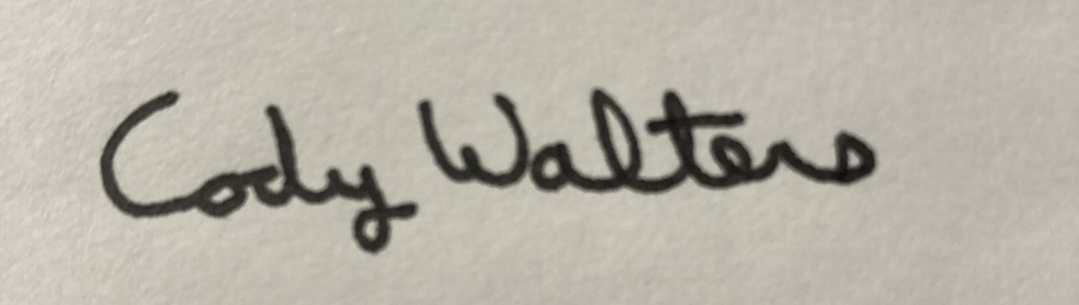
Cody Walters, CPPB
Associate Procurement Specialist
CodyWalters@elpasoco.com
719-520-5693

