FINAL AWARD NOTIFICATION

RFP-26-003
Vollmer Road and Burgess Road Intersection Improvement Project

Contract Term: March 17, 2017 thru December 31, 2030

Piggyback Contract: Yes

PURCHASE BY OTHER GOVERNMENTAL AGENCIES: Each governmental unit which avails itself of this Solicitation will establish its own contact, place its own orders, issue its own purchase orders, be invoiced there from, and make its own payments and issue its own exemption certifications as required by the Vendor. It is understood and agreed that El Paso County is not a legally binding party to any contractual agreement made between any other governmental unit and the Vendor as a result of this Solicitation.

Awarded To: Olsson, Inc.
Karen Aspelin, P.E., PTOE
121 South Tejon Street, Suite 1111
Colorado Springs, CO 80903

kaspelin@olsson.com
719-661-4127

Procurement Contact: Cody Walters, CPPB
Procurement Specialist
CodyWalters@elpasoco.com
719-520-6593

Approved By:

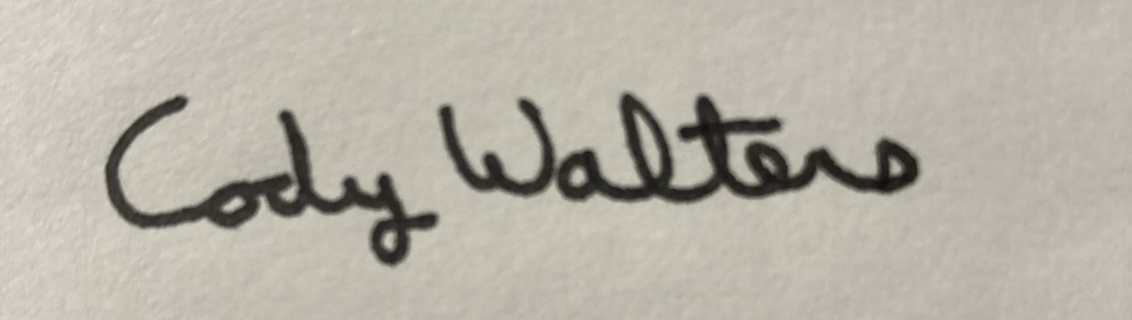 3/31/2026
________________________________________________________ _____________________
Cody Walters, CPPB, Procurement Specialist Date

