March 13, 2026

Brian Smith
Partner | Executive Vice President – Employee Benefits
USI Insurance Services
1 S. Nevada Avenue, Suite 230,
Colorado Springs, Colorado 80903

Dear Mr. Smith,

Thank you for your interest in providing El Paso County with Benefits Consulting Services.

Based on El Paso County’s assessment of your submittal in response to our Request for Proposal, your firm has been selected to negotiate a contract with El Paso County, Colorado.

We will be in contact with your firm within the next few weeks to begin the process of negotiating a contract and the establishment of an implementation plan for Benefits Consulting Services.

In addition, you are requested to furnish within two (2) weeks of receipt of this letter, Certificates of Insurance evidencing compliance with El Paso County’s requirements for insurance and a copy of your current proof of registration with State of Colorado.

We appreciate your interest in doing business with El Paso County and encourage you to continue to apply for future opportunities.

Sincerely,

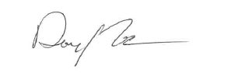

Danny Tesh
Associate Procurement Specialist
DannnyTesh@elpasoco.com
719-520-6772

