Invitation for Bid #IFB-26-001
For
High Build Traffic Paint and Glass Beads

Opening Date & Time: Wednesday, March 11, 2026 at 3:00 p.m.

Mandatory Requirements:
- Proprietary / Confidential Statement
- Contractor Information Form
- Sub-contractor List, if applicable
- Exhibit 1-4
- Completed Signed Cover Sheet
- Addendum Acknowledgment
- Bid Form
- Product Specifications

Vendor Name | Signed | Addendum (1) | Requirements Met | Option #1 | Option #2 | Option #3
All States Coatings Co. | Yes | Yes | Yes | $6,123.00 | No Bid | No Bid
Crown USA, Inc. | Yes | Yes | Yes | $5,825.00 | $0.94 | $4.00
Potters Industries, LLC | Yes | Yes | No | N/A | N/A | N/A
The Sherwin-Williams Company | Yes | Yes | Yes | $7,075.00 | No Bid | No Bid

Public Opening: Yes

Verified and Acknowledged for completeness and accuracy:
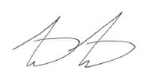 03/19/2026
Matthew Marter, CPPB, Senior Procurement Specialist Date
El Paso County, Colorado – Contracts and Procurement Division

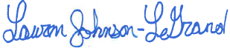 3/19/2026
Lauren Johnson-LeGrand, Administrative Specialist Date
El Paso County, Colorado – Contracts and Procurement Division

