February 9, 2026

Data Destruction Inc.
150 Capital Drive, Ste 390
Jamie Crozier

Dear Mr. or Mrs. Crozier

Thank you for your interest in providing El Paso County with Shredding Services

Based on El Paso County’s assessment of your submittal in response to our Request for Proposal, your firm has been selected to negotiate a contract with El Paso County, Colorado.

We will be in contact with your firm within the next few weeks to begin the process of negotiating a contract and the establishment of an operations plan for the Shredding Services.

In addition, you are requested to furnish within two (2) weeks of receipt of this letter, Certificates of Insurance evidencing compliance with El Paso County’s requirements for insurance and a copy of your current proof of registration with State of Colorado.

We appreciate your interest in doing business with El Paso County and encourage you to continue to apply for future opportunities.

Sincerely,

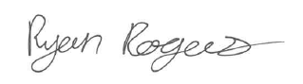

Ryan Rogers
Associate Procurement Specialist
RyanRogers2@elpasoco.com

