Request for Proposal #RFP-25-106
For
Professional Auditing Services

Opening Date & Time: Wednesday, December 3, 2025 at 2:00 p.m.

Mandatory Requirements:

• Signed Cover Sheet from this Solicitation
• Consultant Information Form
• Proprietary / Confidential Statement
• Submission Form
• Exhibit 1 – Exception Form
• Exhibit 2 – Lobbying Certification

• Exhibit 3 – Non-Collusion Affidavit
• Exhibit 4 – Minimum Insurance Requirements
• Copy of Valid and Active Colorado Water Operator Certification
• Attachment C - Fee Proposal Spreadsheet
• Certificate of Good Standing
• ORC Designation Form

Vendor Name | Signed | Addendum (N/A) | Requirements Met
Altitude Water LLC | Yes | N/A | Yes

Public Opening: Yes

Verified and Acknowledged for completeness and accuracy:
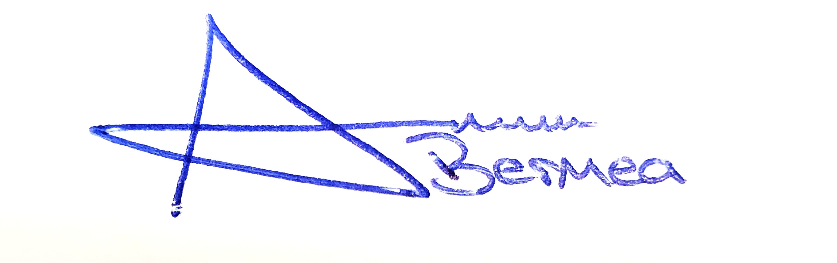 12/8/2025

Arron Bermea, Associate Procurement Specialist Date
El Paso County, Colorado – Contracts and Procurement Division

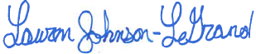 12/08/2025

Lauren Johnson-LeGrand, Administrative Specialist Date
El Paso County, Colorado – Contracts and Procurement Division

