FINAL AWARD NOTIFICATION

RFP-25-106
El Paso County Public Water System ORC Services

Term of Agreement: One-year with the option to renew for four additional one-year terms

Initial Contract Term: January 1, 2026 thru December 31, 2026

Piggyback Contract: No

PURCHASE BY OTHER GOVERNMENTAL AGENCIES: Each governmental unit which avails itself of this Solicitation will establish its own contact, place its own orders, issue its own purchase orders, be invoiced therefrom, and make its own payments and issue its own exemption certifications as required by the Vendor. It is understood and agreed that El Paso County is not a legally binding party to any contractual agreement made between any other governmental unit and the Vendor as a result of this Solicitation.

Awarded To: Altitude Water, LLC
Chad Forsett, Owner/Operator
1209 Doyle Place
Colorado Springs, CO 80915
altitudewaterllc@gmail.com
719.357.2506

Procurement Contact: Arron Bermea
Associate Procurement Specialist
arronbermea2@elpasoco.com
719-520-6489

Approved By:

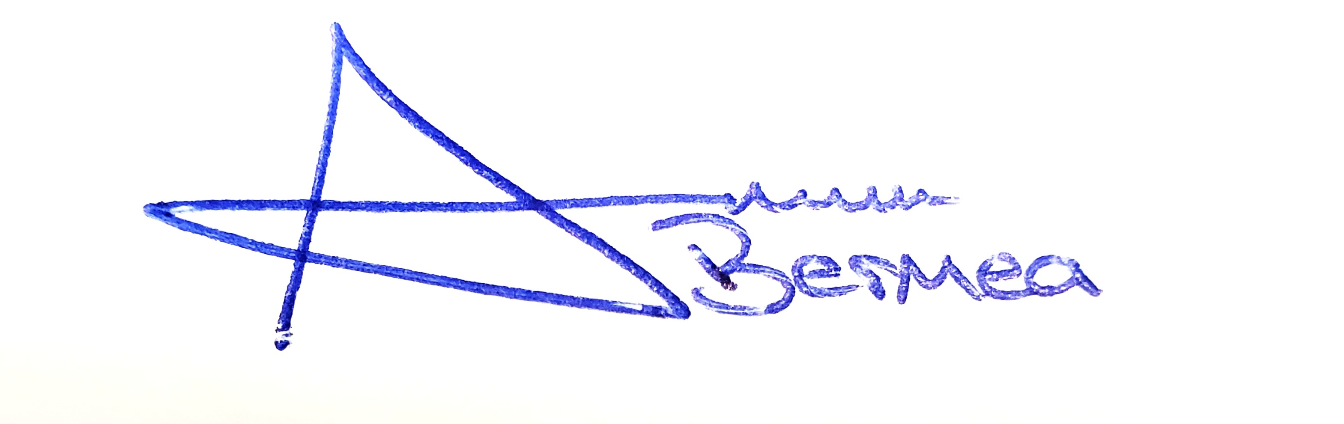
________________________________________________________ ______01/28/2026_______
Arron Bermea, Associate Procurement Specialist Date

