Request for Proposal #RFP-25-098
For
Fleet Hydraulic Repairs and Parts

Opening Date & Time: Wednesday, November 5, 2025 at 2:00 p.m.

Mandatory Requirements:

- Cover Sheet
- Addendum
- Vendor Information Form
- Proprietary / Confidential Statement
- Evaluation Criteria Documentation
- Exhibits 1-4

Vendor Name | Signed | Addendum (1) | Requirements Met
SunSource | Yes | Yes | Yes

Public Opening: Yes

Verified and Acknowledged for completeness and accuracy:
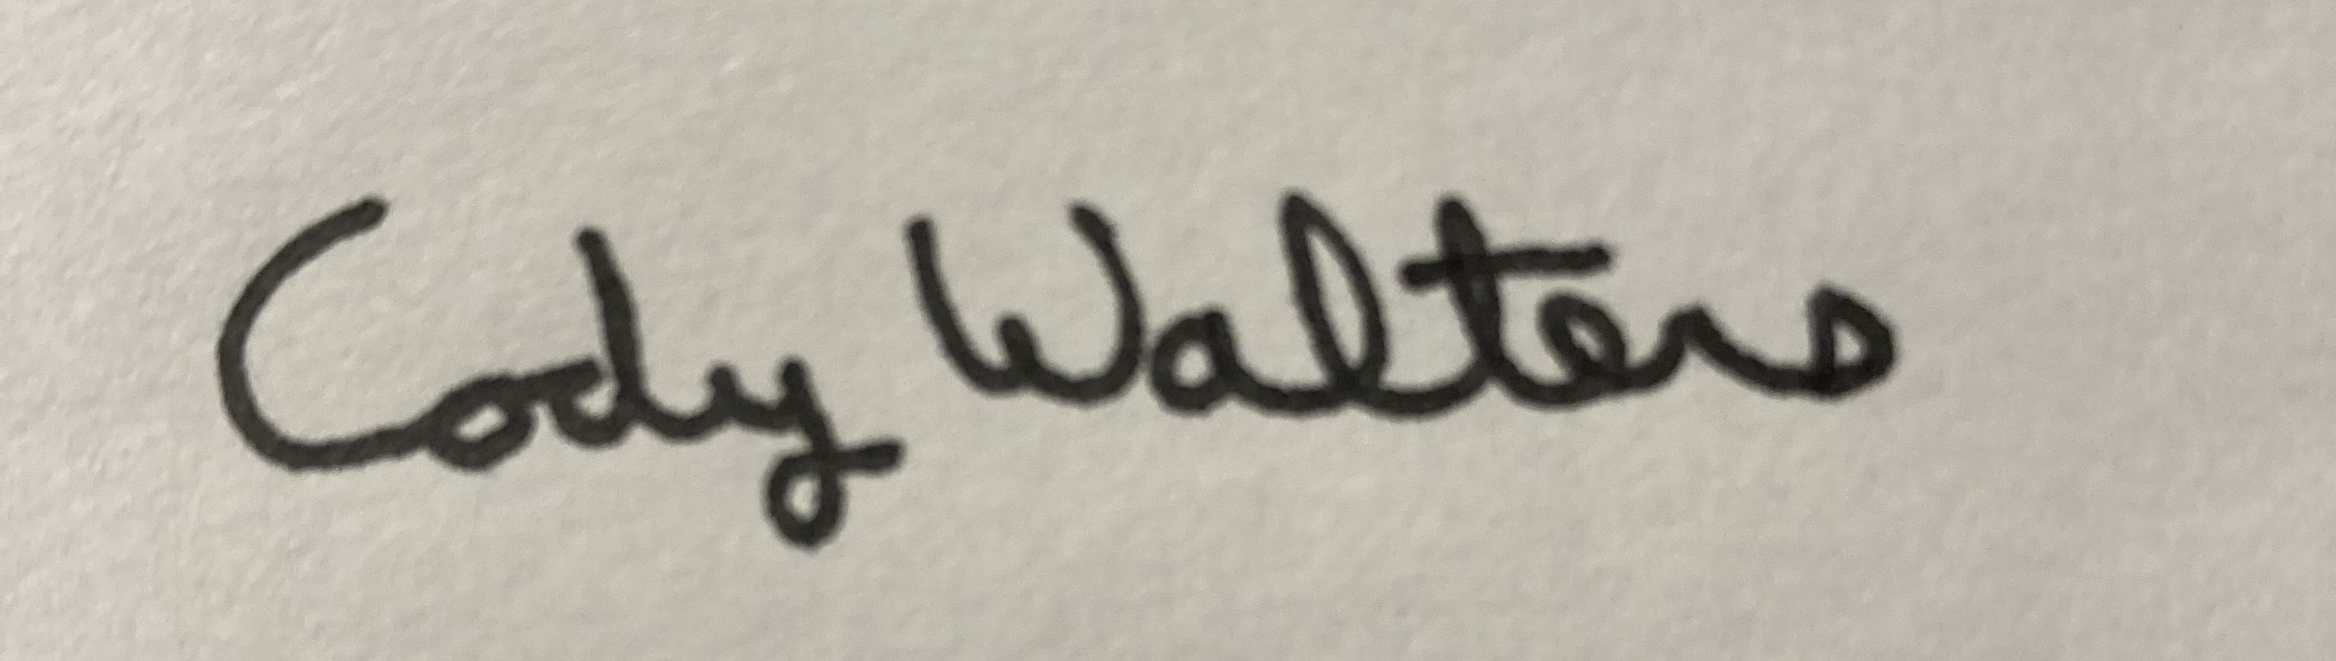 11/5/2025

Cody Walters, CPPB, Associate Procurement Specialist Date
El Paso County, Colorado – Contracts and Procurement Division

 11/5/2025

Lauren Johnson-LeGrand, Administrative Specialist Date
El Paso County, Colorado – Contracts and Procurement Division

