January 9, 2026

Keefe Commissary Network, LLC
Teresa Vitale
13870 Corporate Woods Trail
Bridgeton, MO 63044
Teresa.vitale@keefegroup.com

Dear Ms. Vitale,

Thank you for your interest in providing El Paso County with the proposal for Inmate Commissary and Banking Services.

Based on El Paso County’s assessment of your submittal in response to our Request for Proposal, your firm has been selected to negotiate a contract with El Paso County, Colorado.

We will be in contact with your firm within the next few weeks to begin the process of negotiating a contract and the establishment of an operations plan for the Inmate Commissary and Banking Services.

In addition, you are requested to furnish within two (2) weeks of receipt of this letter, Certificates of Insurance evidencing compliance with El Paso County’s requirements for insurance and a copy of your current proof of registration with State of Colorado.

We appreciate your interest in doing business with El Paso County and encourage you to continue to apply for future opportunities.

Sincerely,

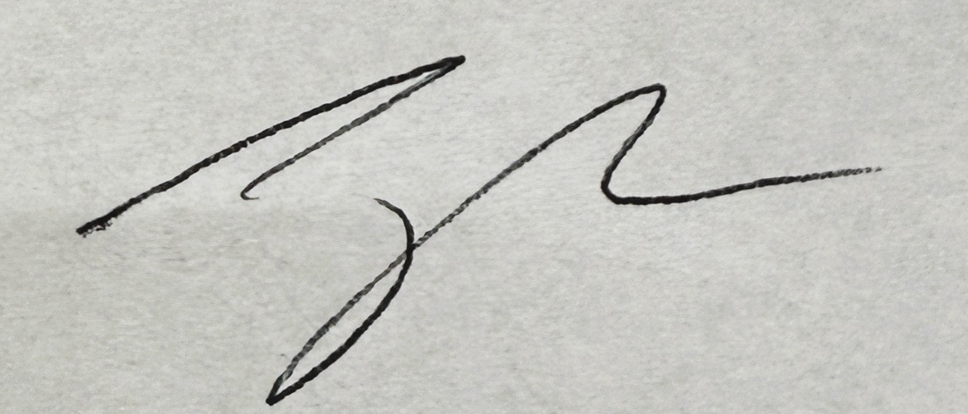

Jake Harper, CPPB
Associate Procurement Specialist
719-520-6857
JakeHarper@elpasoco.com

