FINAL AWARD NOTIFICATION

RFP-25-094
Inmate Commissary and Banking Services

Term of Agreement: Eight Months with the option to renew for four additional one-year terms

Initial Contract Term: April 23, 2026 thru December 31, 2026

Piggyback Contract: Yes

PURCHASE BY OTHER GOVERNMENTAL AGENCIES: Each governmental unit which avails itself of this Solicitation will establish its own contact, place its own orders, issue its own purchase orders, be invoiced there from, and make its own payments and issue its own exemption certifications as required by the Vendor. It is understood and agreed that El Paso County is not a legally binding party to any contractual agreement made between any other governmental unit and the Vendor as a result of this Solicitation.

Awarded To: Keefe Commissary Network, LLC
Teresa Vitale
13870 Corporate Woods Trail
Bridgeton, MO 63044
Teresa.vitale@keefegroup.com

Procurement Contact: Jake Harper, CPPB
Procurement Specialist
JakeHarper@elpasoco.com
719-520-6857

Approved By:

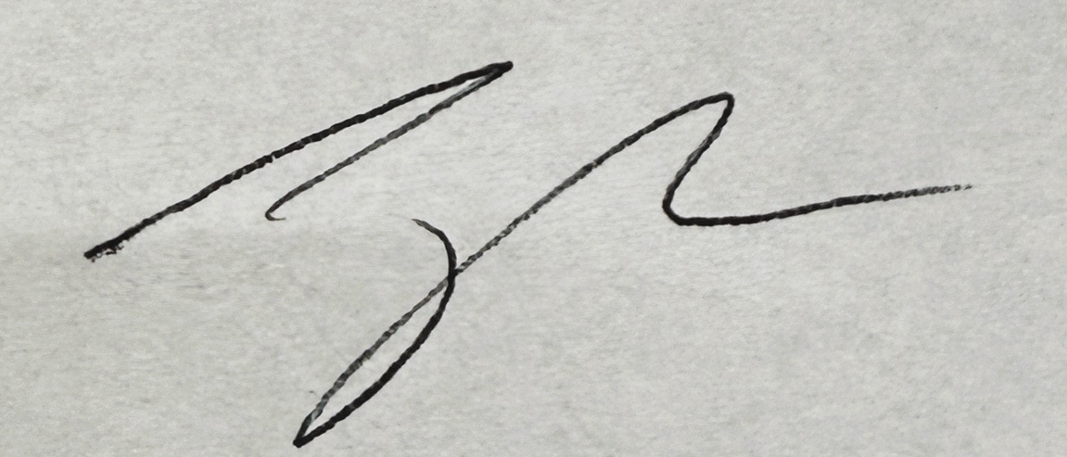 4/23/2026
________________________________________________________ _____________________
Jake Harper, CPPB, Procurement Specialist Date

