FINAL AWARD NOTIFICATION

RFP-25-087
El Paso County Stormwater Master Drainage Plan

Term of Agreement: Three Years

Initial Contract Term: January 13, 2026 thru December 31, 2028

Piggyback Contract: Yes

PURCHASE BY OTHER GOVERNMENTAL AGENCIES: Each governmental unit which avails itself of this Solicitation will establish its own contact, place its own orders, issue its own purchase orders, be invoiced there from, and make its own payments and issue its own exemption certifications as required by the Vendor. It is understood and agreed that El Paso County is not a legally binding party to any contractual agreement made between any other governmental unit and the Vendor as a result of this Solicitation.

Awarded To: Matrix Design Group, Inc.
Peter Keiser, Proposal Coordinator
2435 Research Parkway
Colorado Springs, CO 80920

peter.keiser@matrixdesigngroup.com
570-939-2394

Procurement Contact: Cody Walters, CPPB
Associate Procurement Specialist
CodyWalters@elpasoco.com
719-520-6593

Approved By:

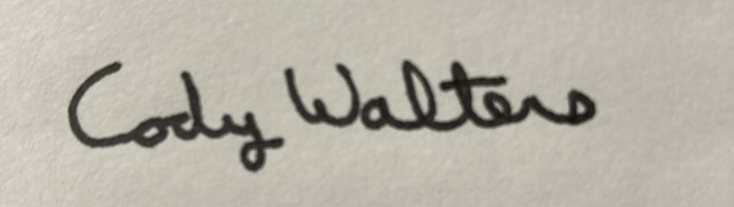 1/14/2026
_________________________________________________ _____________________
Cody Walters, CPPB, Associate Procurement Specialist Date

