November 24, 2025

Chris Martin, GISP
Matrix Design Group, Inc.
2435 Research Pkwy, Suite 300
Colorado Springs, CO 80920
matrix@matrixdesigngroup.com

Dear Mr. Martin,

Thank you for your interest in providing El Paso County with El Paso County Parks Asset Inventory and Condition Assessment.

Based on El Paso County’s assessment of your submittal in response to our Request for Proposal, your firm has been selected to negotiate a contract with El Paso County, Colorado.

We will be in contact with your firm within the next few weeks to begin the process of negotiating a contract and the establishment of an operations plan for El Paso County Parks Asset Inventory and Condition Assessment.

In addition, you are requested to furnish within two (2) weeks of receipt of this letter, Certificates of Insurance evidencing compliance with El Paso County’s requirements for insurance..

We appreciate your interest in doing business with El Paso County and encourage you to continue to apply for future opportunities.

Sincerely,

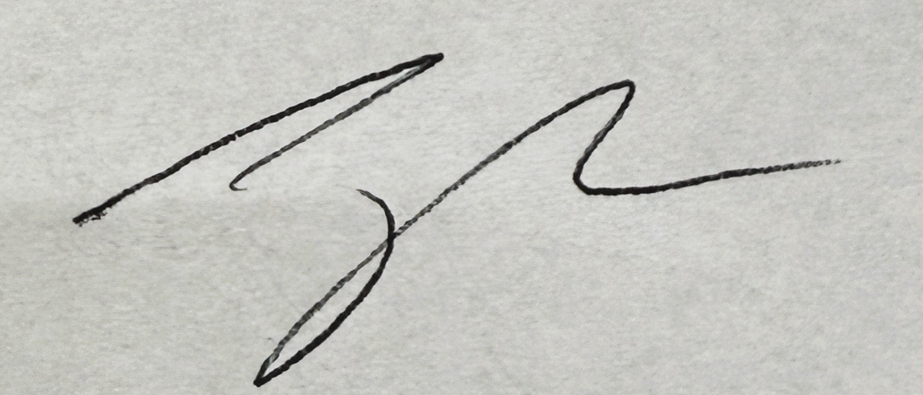

Jake Harper, CPPB
Associate Procurement Specialist
JakeHarper@elpasoco.com
719-520-6857

