FINAL AWARD NOTIFICATION

RFP-25-085
Parks Asset Inventory and Condition Assessment

Term of Agreement: Nine Months

Initial Contract Term: January 14, 2026 - September 30, 2026

Piggyback Contract: Yes

PURCHASE BY OTHER GOVERNMENTAL AGENCIES: Each governmental unit which avails itself of this Solicitation will establish its own contact, place its own orders, issue its own purchase orders, be invoiced there from, and make its own payments and issue its own exemption certifications as required by the Vendor. It is understood and agreed that El Paso County is not a legally binding party to any contractual agreement made between any other governmental unit and the Vendor as a result of this Solicitation.

Awarded To:
Matrix Design Group, Inc.
2435 Research Pkwy, Suite 300
Colorado Springs, CO 80920
Chris Martin, GISP
Chris_martin@matrixdesigngroup.com

Procurement Contact: Jake Harper, CPPB
Associate Procurement Specialist
JakeHarper@elpasoco.com
719-520-6857

Approved By:

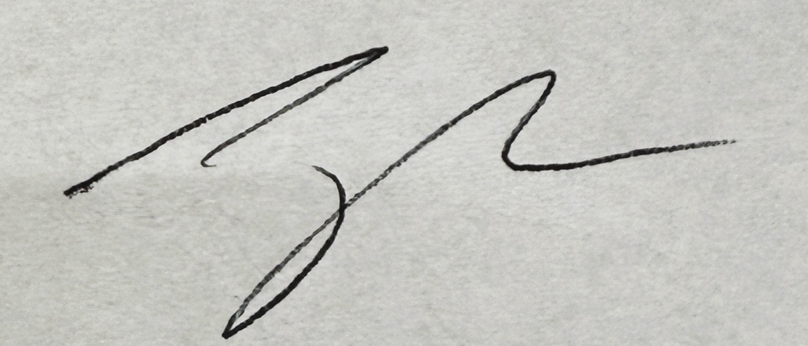 1/14/2026
________________________________________________________ _____________________
Jake Harper, CPPB, Associate Procurement Specialist Date

