Statement of Qualifications #SOQ-25-079
For
Traffic Data Collection

Opening Date & Time: Wednesday, September 10, 2025 at 2:00 p.m.

Mandatory Requirements:

• Signed Cover Sheet from this Solicitation
• Consultant Information Form
• Proprietary / Confidential Statement
• Submission Form
• Exhibit 1 – Exception Form
• Exhibit 2 – Lobbying Certification

• Exhibit 3 – Non-Collusion Affidavit
• Exhibit 4 – Minimum Insurance Requirements
• Addendum(s) Acknowledgement
• Evaluation Criteria Documentation
• Fee Proposal

Vendor Name | Signed | Addendum (1) | Requirements Met
IDAX Data Solutions | Yes | Yes | Yes
National Data and Surveying Services | Yes | Yes | Yes
Quality Traffic Data LLC | Yes | Yes | Yes
All Traffic Data Services | Yes | Yes | Yes

Public Opening: Yes

Verified and Acknowledged for completeness and accuracy:
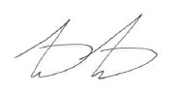 09/10/2025

Matthew Marter, Senior Procurement Specialist Date
El Paso County, Colorado – Contracts and Procurement Division

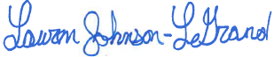 9/10/2025

Lauren Johnson-LeGrand, Administrative Specialist Date
El Paso County, Colorado – Contracts and Procurement Division

