October 30, 2025

Attn: Brad Bettag - PE
Wilson & Company Inc., Engineers & Architects
5755 Mark Dabling Blvd, Suite 100
Colorado Springs, CO 80919

Dear Mr. Bettag,

Thank you for your interest in providing El Paso County with the Haegler Ranch, Geick Ranch, and Ellicott Consolidated Drainage Basin Planning Study.

Based on El Paso County’s assessment of your submittal in response to our Request for Proposal, your firm has been selected to negotiate a contract with El Paso County, Colorado.

We will be in contact with your firm within the next few weeks to begin the process of negotiating a contract and the establishment of an operations plan for the Haegler Ranch, Geick Ranch, and Ellicott Consolidated Drainage Basin Planning Study..

In addition, you are requested to furnish within two (2) weeks of receipt of this letter, Certificates of Insurance evidencing compliance with El Paso County’s requirements for insurance and a copy of your current proof of registration with State of Colorado.

We appreciate your interest in doing business with El Paso County and encourage you to continue to apply for future opportunities.

Sincerely,
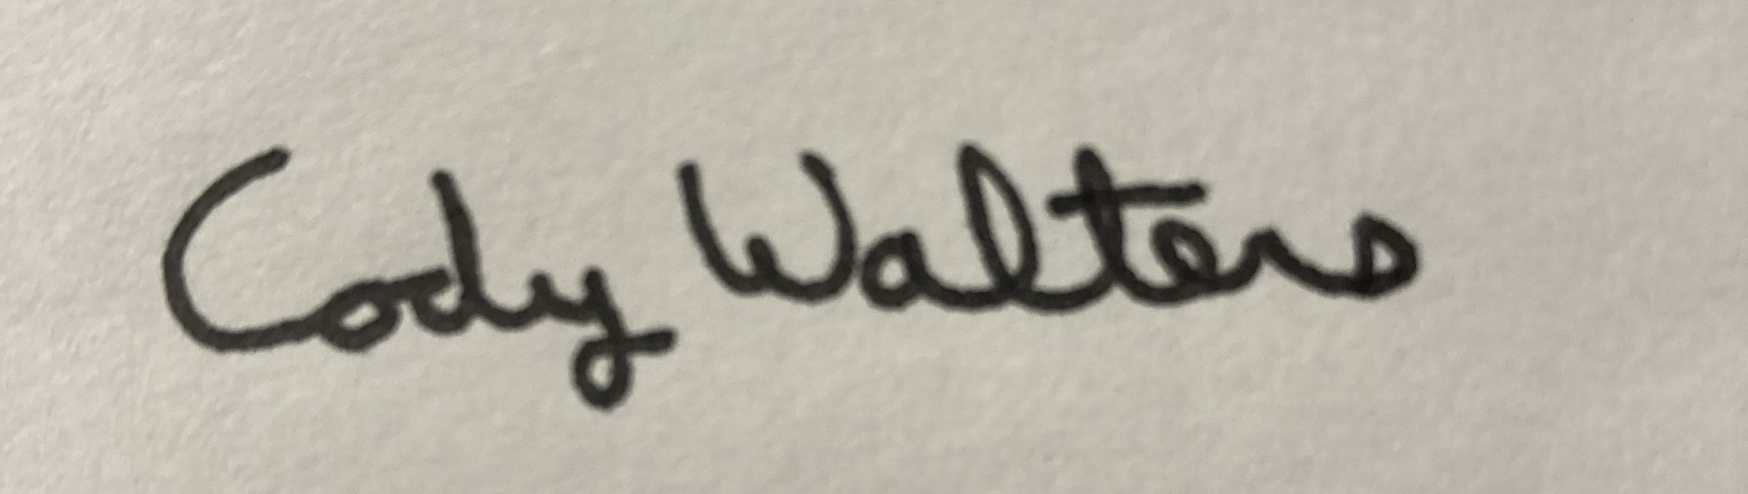
Cody Walters
Associate Procurement Specialist
CodyWalters@elpasoco.com
719-520-5693

