Request for Proposal #RFP-25-077
For
Haegler Ranch, Geick Ranch, and Ellicott Consolidated Drainage Basin Planning Study

Opening Date & Time: Wednesday, September 17, 2025 at 1:00 p.m.

Mandatory Requirements:

Replacement Cover Sheet
Addendums 1 & 2 Acknowledged
Consultant Information Form
Proprietary / Confidential Statement
Exhibits 1-4

Vendor Name | Signed | Addendum (1 & 2) | Requirements Met
AECOM | Yes | Yes | Yes
Kimley-Horn and Associates, Inc | Yes | Yes | Yes
Wilson & Company Inc., Engineers & Architects | Yes | Yes | Yes

Public Opening: Yes

Verified and Acknowledged for completeness and accuracy:

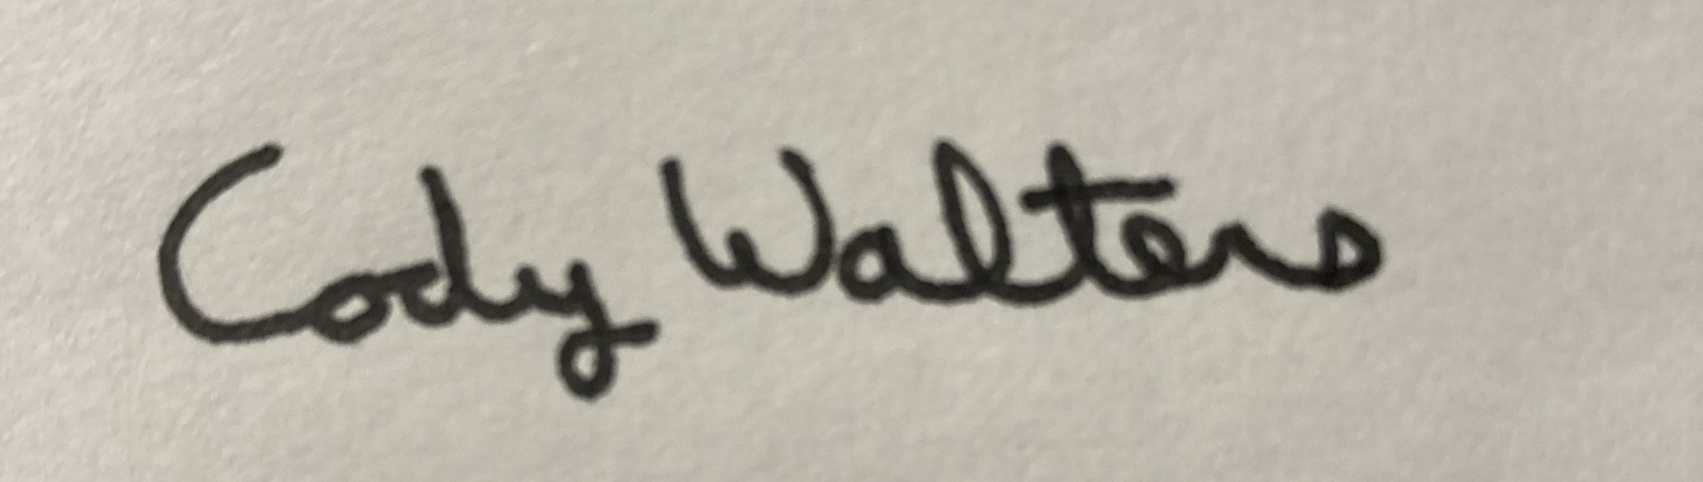 9/17/2025

Cody Walters, Associate Procurement Specialist Date
El Paso County, Colorado – Contracts and Procurement Division

 9/17/2025

Lauren Johnson-Legrand, Administrative Specialist Date
El Paso County, Colorado – Contracts and Procurement Division

