Request for Proposal #RFP-25-073
For
A Closer Peek at Bear Creek Exhibit
Opening Date & Time: Wednesday, November 19th, 2025 at 2:00 p.m.

Mandatory Requirements:

• Signed Cover Sheet from this Solicitation
• Consultant Information Form
• Proprietary / Confidential Statement
• Submission Form
• Exhibit 1 – 4
• Addendum(s) Acknowledgement
• Copies of requested Insurance Certificates (COI)
• Certificate of Good Standing
• W-9 Documentation
• Attachment C – Fee Schedule
• One-Year Warranty Information

Vendor Name | Signed | Addendum (1) | Requirements Met
Condit Exhibits | Yes | Yes | Yes
Ideum Inc | No | Yes | No

Public Opening: Yes

Verified and acknowledged for completeness and accuracy:
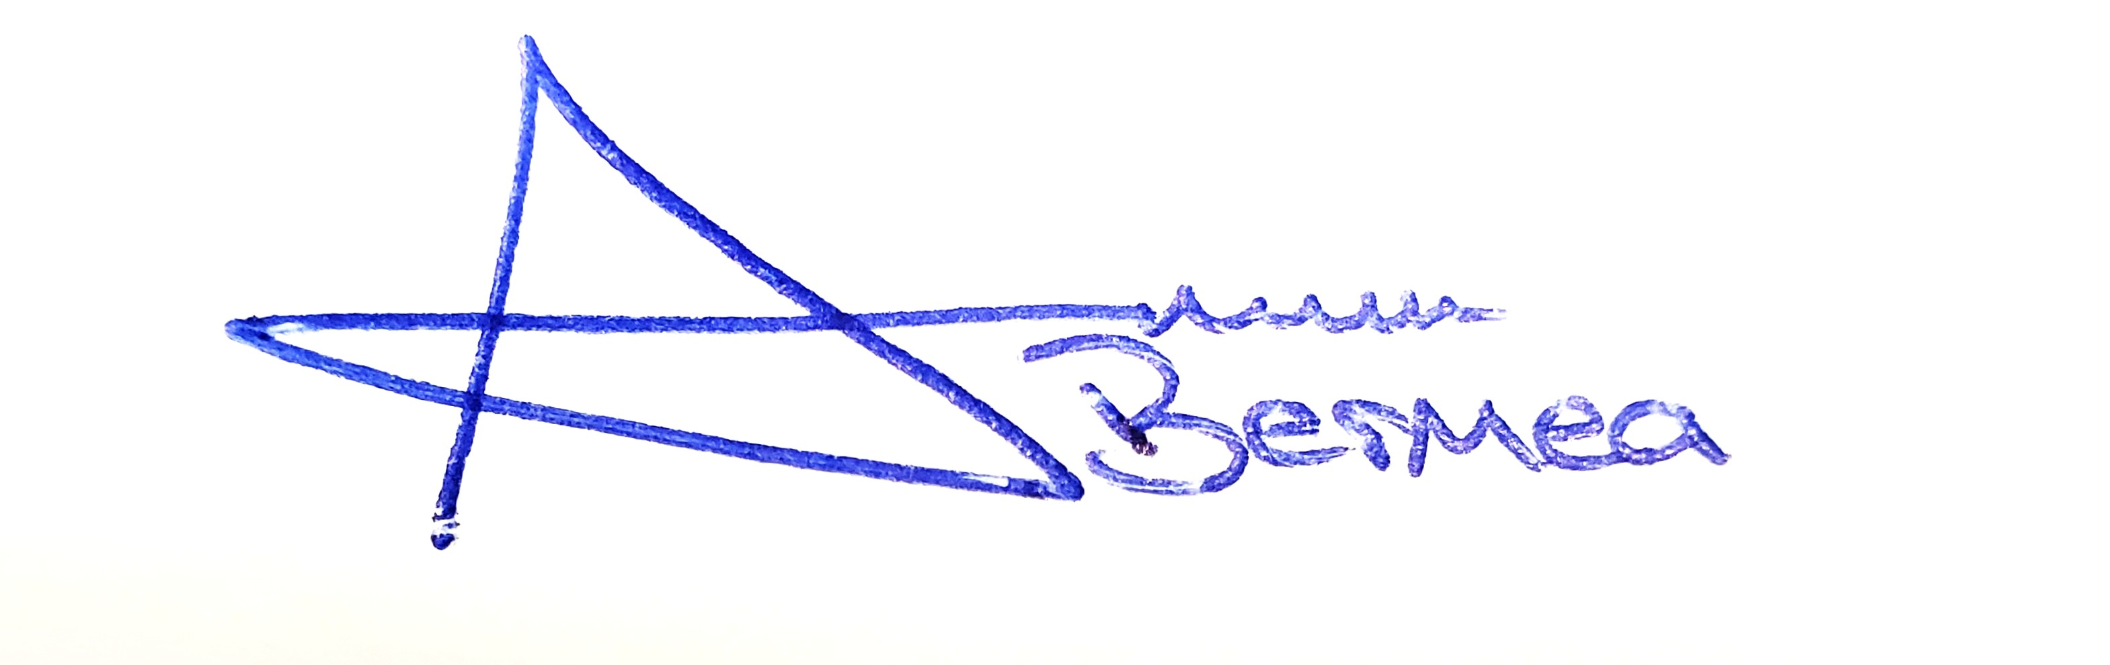

Arron Bermea, Associate Procurement Specialist Date
El Paso County, Colorado – Contracts and Procurement Division

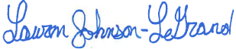 11/20/2025

Lauren Johnson-LeGrand, Administrative Coordinator Date
El Paso County, Colorado – Contracts and Procurement Division

