FINAL AWARD NOTIFICATION

RFP-25-073
A Closer Peek at Bear Creek Exhibit

Term of Agreement: As stated in Trade Contractor Agreement RFP-25-073

Initial Contract Term: January 12, 2026 thru April 30, 2026

Piggyback Contract: No

PURCHASE BY OTHER GOVERNMENTAL AGENCIES: Each governmental unit which avails itself of this Solicitation will establish its own contact, place its own orders, issue its own purchase orders, be invoiced therefrom, and make its own payments and issue its own exemption certifications as required by the Vendor. It is understood and agreed that El Paso County is not a legally binding party to any contractual agreement made between any other governmental unit and the Vendor as a result of this Solicitation.

Awarded To: Condit Exhibits, LLC
Jenny Koehn, President
5151 Bannock St.
Denver, CO 80216
jkoehn@condit.com
303.744.7167

Procurement Contact: Arron Bermea
Associate Procurement Specialist
ArronBermea2@elpasoco.com
719-520-6489

Approved By:

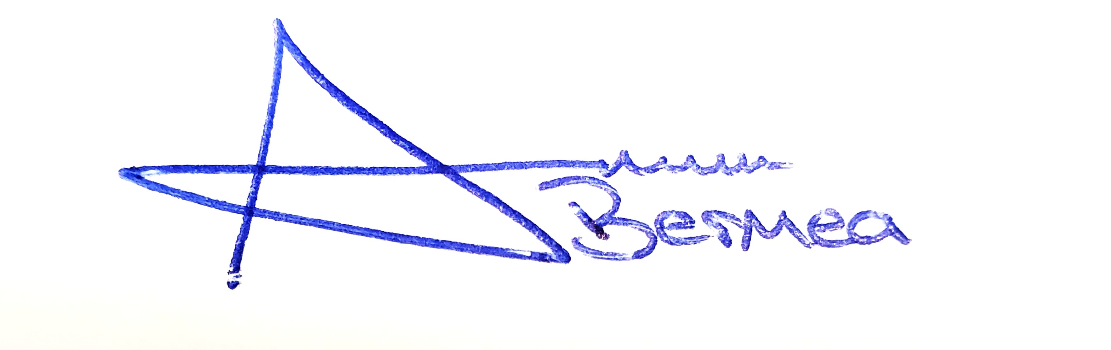
________________________________________________________ _____01/12/2026______
Arron Bermea, Associate Procurement Specialist Date

