FINAL AWARD NOTIFICATION

IFB-25-072
Electronics Dismantle and Recycling

Term of Agreement: One-year with the option to renew for four additional one-year terms

Initial Contract Term: January 1, 2026 thru August 31, 2026

Piggyback Contract: No

PURCHASE BY OTHER GOVERNMENTAL AGENCIES: Each governmental unit which avails itself of this Solicitation will establish its own contact, place its own orders, issue its own purchase orders, be invoiced there from, and make its own payments and issue its own exemption certifications as required by the Vendor. It is understood and agreed that El Paso County is not a legally binding party to any contractual agreement made between any other governmental unit and the Vendor as a result of this Solicitation.

Awarded To: PedalPoint EvTerra Recycling, LLC dba PedalPoint LifeCycle Solutions
Zack Boorstein, Vice President
3251 Lewiston St. Suite 10
Aurora, CO 80011
zackb@pedalpoint.co
405-509-0069

Procurement Contact: Arron Bermea
Associate Procurement Specialist
ArronBermea2@elpasoco.com
719-520-6489

Approved By:

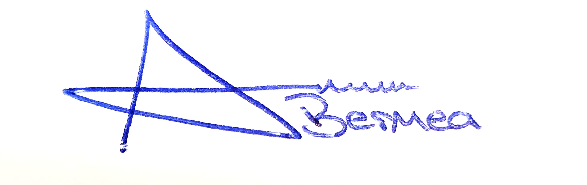
_______________________________________________________ _________10/23/2025___
Arron Bermea, Associate Procurement Specialist Date

