Request for Proposal #RFP-25-069
For
Race Operator Services for Fairgrounds Auto Race Program
Opening Date & Time: Wednesday, September 17, 2025, at 3:00 p.m.

Mandatory Requirements:

- Signed Cover Sheet from this Solicitation
- Consultant Information Form
- Proprietary / Confidential Statement
- Exhibit 1 – 4
- Business Plan
- Example Certificate of Insurance
- Signed Attachment A
- Addendum(s) Acknowledgement
- Submission Form

- Financial Interest Statement
- Details of the Contractor’s Experience and Qualifications as described in the Evaluation Criteria
- Universal Entity Identifier (UEI) Number
- Fee Proposal
- Certificate of Good Standing
- W-9 Documentation

Vendor Name | Signed | Addendum (3) | Requirements Met
BST Promotions | YES | YES | YES

Public Opening: Yes

Verified and Acknowledged for completeness and accuracy:

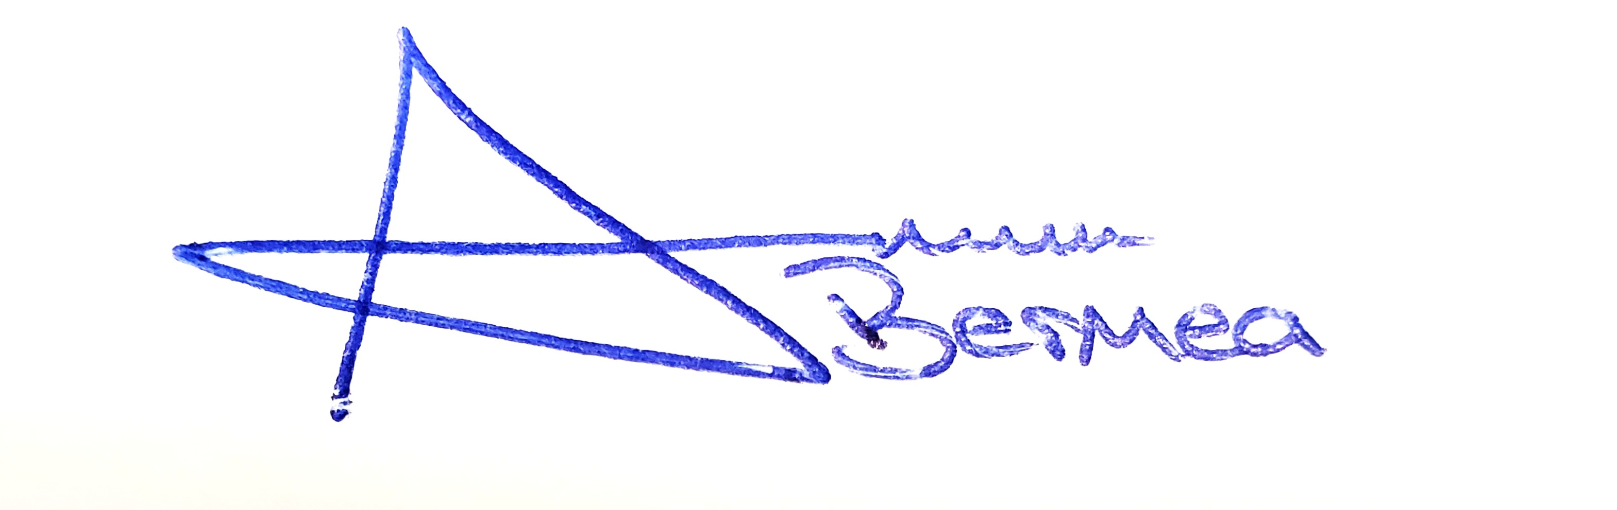 09/23/2025

Arron Bermea, Associate Procurement Specialist Date
El Paso County, Colorado – Contracts and Procurement Division

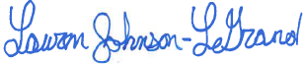 09/23/2025

Lauren Johnson-LeGrand, Administrative Coordinator Date
El Paso County, Colorado – Contracts and Procurement Division

