FINAL AWARD NOTIFICATION

RFP-25-069
Race Operator Services for Fairgrounds Auto Race Program

Term of Agreement: One-year with the option to renew for four additional one-year terms

Initial Contract Term: January 1, 2026 thru December 31, 2026

Piggyback Contract: No

PURCHASE BY OTHER GOVERNMENTAL AGENCIES: Each governmental unit which avails itself of this Solicitation will establish its own contact, place its own orders, issue its own purchase orders, be invoiced there from, and make its own payments and issue its own exemption certifications as required by the Vendor. It is understood and agreed that El Paso County is not a legally binding party to any contractual agreement made between any other governmental unit and the Vendor as a result of this Solicitation.

Awarded To: BB Investments, dba BST Promotions
Joe Bellm, Owner
1881 W. 149th Ave
Broomfield, CO 80023
joe@bstracing.com
720-404-0400

Procurement Contact: Arron Bermea
Associate Procurement Specialist
ArronBermea2@elpasoco.com
719-520-6489

Approved By:

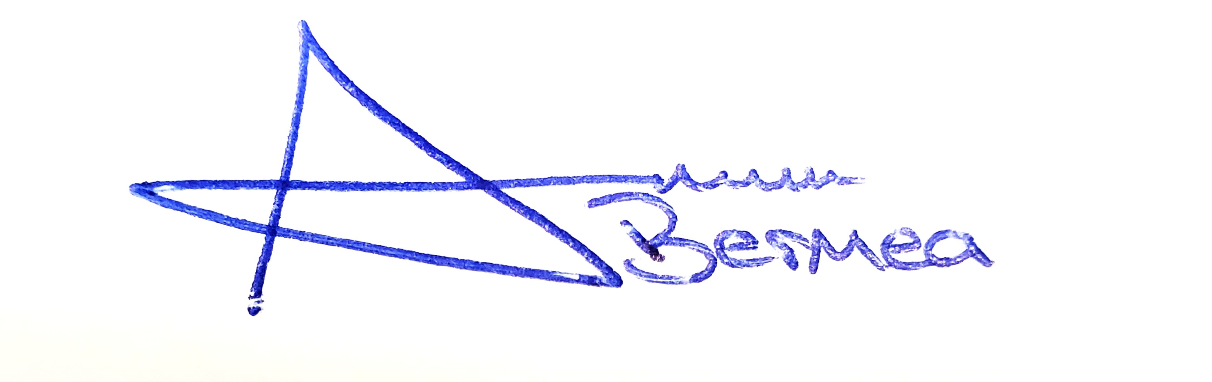 11/13/2025
________________________________________________________ _____________________
Arron Bermea, Associate Procurement Specialist Date

