FINAL AWARD NOTIFICATION

RFP 25-066
Transportation Services

Term of Agreement: One-year with the option to renew for four additional one-year terms

Initial Contract Term: November 1, 2025 thru June 30, 2026

Piggyback Contract: Yes

PURCHASE BY OTHER GOVERNMENTAL AGENCIES: Each governmental unit which avails itself of this Solicitation will establish its own contact, place its own orders, issue its own purchase orders, be invoiced there from, and make its own payments and issue its own exemption certifications as required by the Vendor. It is understood and agreed that El Paso County is not a legally binding party to any contractual agreement made between any other governmental unit and the Vendor as a result of this Solicitation.

Awarded To: River North Transit LLC
Greg Centini
114th 5th Ave, Fl 17
New York, New York, 10011

Procurement Contact: Ryan Rogers
Associate Procurement Specialist
RyanRogers2@elpasoco.com
719-318-4635

Approved By:

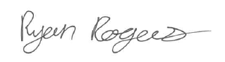 10/8/25
________________________________________________________ _____________________
Ryan Rogers, Associate Procurement Specialist Date

