Statement of Qualifications 25-061

For

County Wide On-Call Striping and Signage

Opening Date & Time: Wednesday, July 9, 2025 at 1:00 p.m.

Mandatory Requirements:

* Signed Cover Sheet
* Addendum Acknowledged
* Contractor Information Form
* Proprietary/Confidential Statement
* Exhibits 1-4
* Questionnaire

|  |  |  |  |
| --- | --- | --- | --- |
| Vendor Name | Signed | Addendum (1) | Requirements Met |
| RoadSafe Traffic Systems, Inc | Yes | Yes | Yes |
|  |  |  |  |
|  |  |  |  |

Public Opening: Yes­­­­­­­­­

Verified and Acknowledged for completeness and accuracy:

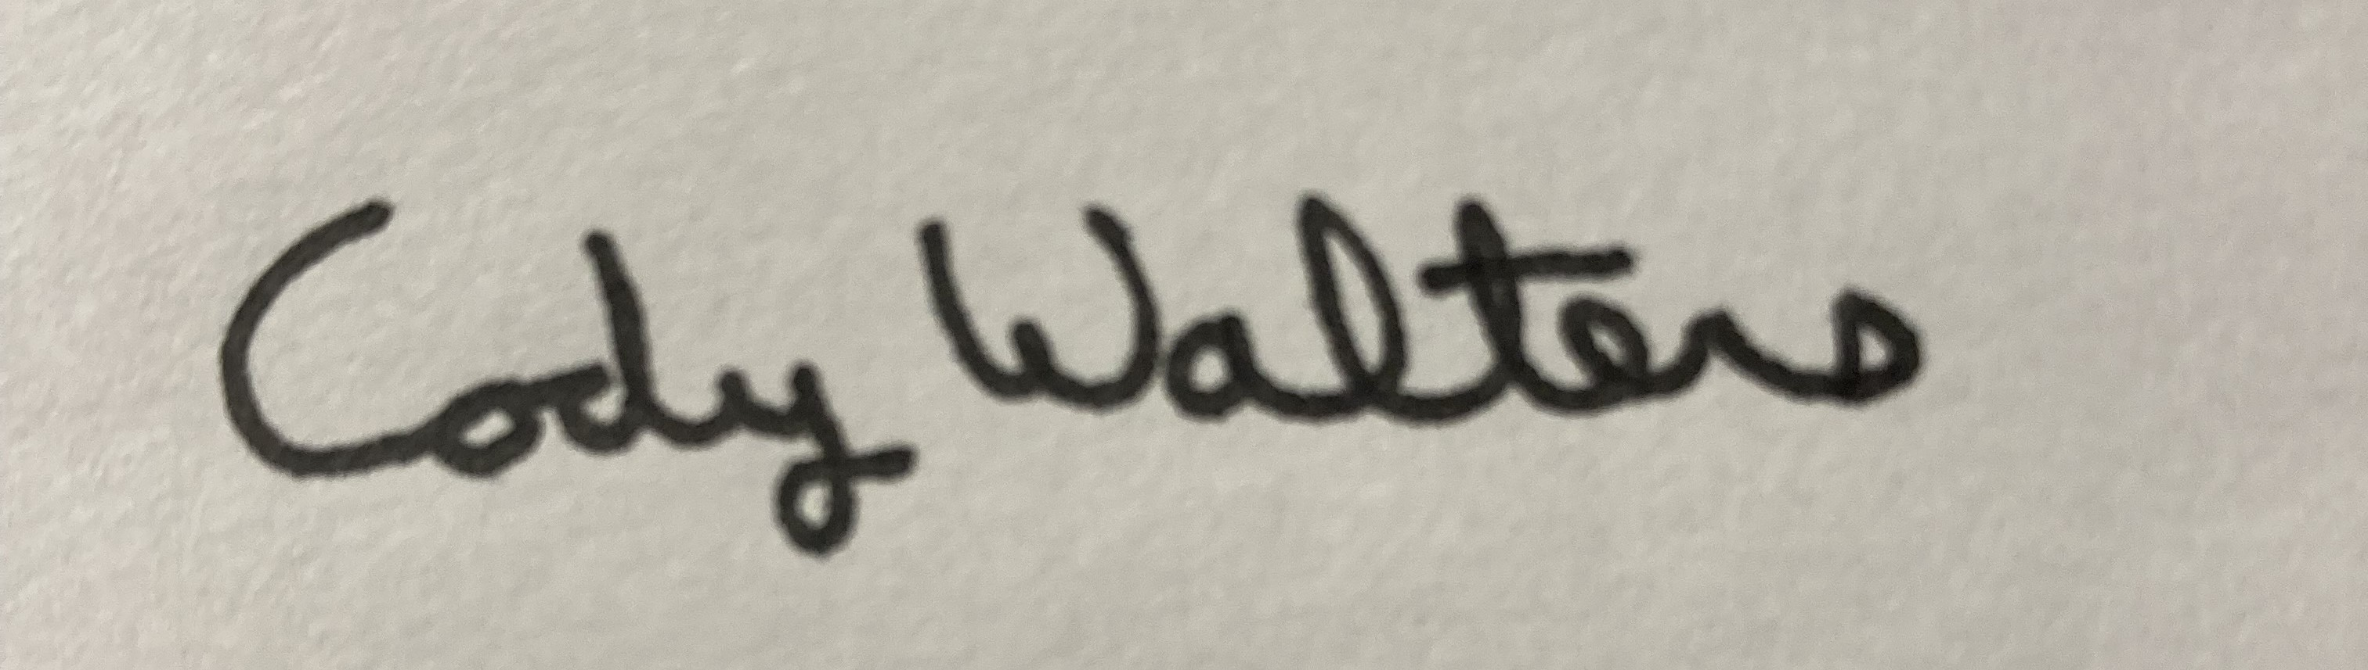 7/9/2025

Cody Walters, Associate Procurement Specialist Date

El Paso County, Colorado – Contracts and Procurement Division

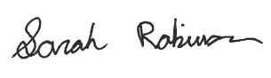 7/9/2025

Sarah Robinson, Administrative Coordinator Date

El Paso County, Colorado – Contracts and Procurement Division