Request for Proposal #RFP-25-060
For
Child Support Services

Opening Date & Time: Wednesday, July 30, 2025 at 11:00 a.m.

Mandatory Requirements:

• Consultant information Form
• Proprietary / Confidential Statement
• Exhibit 1 – Exceptions Form
• Exhibit 2 – Lobbying Restriction Certification
• Exhibit 3 – Non-Collusion Affidavit
• Exhibit 4 – Minimum Insurance Requirements

• Exhibit 5–Debarment Certification
• Proof of Sam.gov Good Standing
• Fee Proposal
• Addendum 1
• Addendum 2
• Addendum 3

Vendor Name | Signed | Addendum (3) | Requirements Met
Veritas HHS | X | X | X
YoungWilliams | X | X | X

Public Opening: Yes
Verified and Acknowledged for completeness and accuracy:

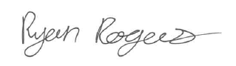
7/31/2025
Ryan Rogers, Associate Procurement Specialist Date
El Paso County, Colorado – Contracts and Procurement Division

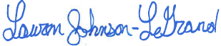
7/30/2025
Lauren Johnson-LeGrand, Administrative Specialist Date
El Paso County, Colorado – Contracts and Procurement Division

