July 9, 2025

Felsburg Holt & Ullevig
3 South Tejon Street, Suite 300
Colorado Springs, CO 80903
Attn: Steve Murray
Steve.murray@fhueng.com

Dear Mr. Murray,

Thank you for your interest in providing El Paso County with services for the North Calhan Highway Design Services project.

Based on El Paso County’s assessment of your submittal in response to our Request for Proposal, your firm has been selected to negotiate a contract with El Paso County, Colorado.

We will be in contact with your firm within the next few weeks to begin the process of negotiating a contract and the establishment of an operations plan for North Calhan Highway Design Services.

In addition, you are requested to furnish within two (2) weeks of receipt of this letter, Certificates of Insurance evidencing compliance with El Paso County’s requirements for insurance and a copy of your current proof of registration with State of Colorado.

We appreciate your interest in doing business with El Paso County and encourage you to continue to apply for future opportunities.

Sincerely,

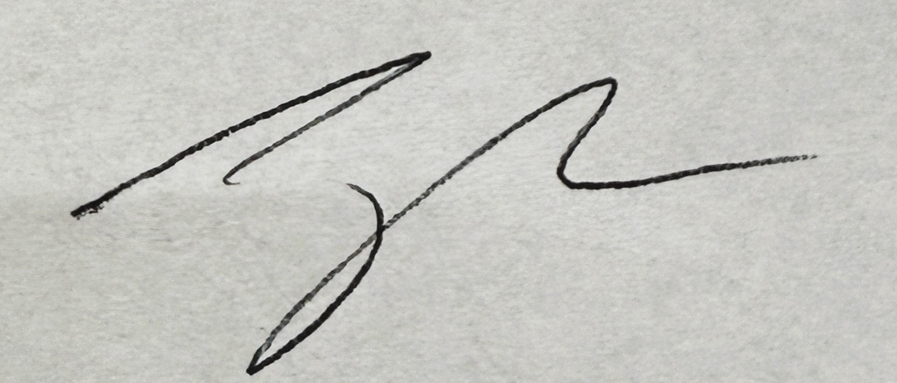

Jake Harper
Associate Procurement Specialist
JakeHarper@elpasoco.com
719-520-6857

