FINAL AWARD NOTIFICATION

RFP 25-056
North Calhan Highway Design Services

Term of Agreement: Multi-Year

Initial Contract Term: August 26, 2025 thru July 31, 2029

Piggyback Contract: Yes

PURCHASE BY OTHER GOVERNMENTAL AGENCIES: Each governmental unit which avails itself of this Solicitation will establish its own contact, place its own orders, issue its own purchase orders, be invoiced there from, and make its own payments and issue its own exemption certifications as required by the Vendor. It is understood and agreed that El Paso County is not a legally binding party to any contractual agreement made between any other governmental unit and the Vendor as a result of this Solicitation.

Awarded To: Felsburg Holt & Ullevig
3 South Tejon Street, Suite 300
Colorado Springs, CO 80903
Attn: Steve Murray
Steve.murray@fhueng.com

Procurement Contact: Jake Harper
Associate Procurement Specialist
JakeHarper@elpasoco.com
719-520-6857

Approved By:
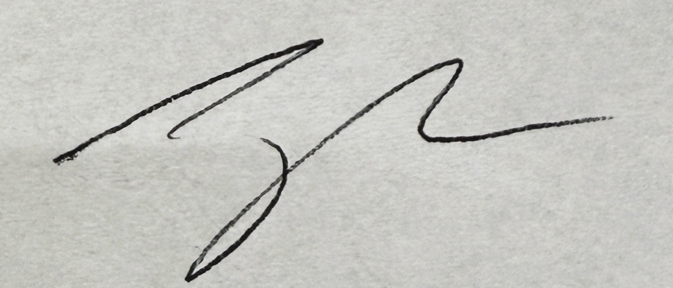
8/28/2025
________________________________________________________ _____________________
Jake Harper, Associate Procurement Specialist Date

