FINAL AWARD NOTIFICATION

IFB-25-054
Construction of the Dean Drive ADA Improvements Project

Term of Agreement: Five Months

Initial Contract Term: July 22, 2025 thru December 31, 2025

Piggyback Contract: Yes

PURCHASE BY OTHER GOVERNMENTAL AGENCIES: Each governmental unit which avails itself of this Solicitation will establish its own contact, place its own orders, issue its own purchase orders, be invoiced there from, and make its own payments and issue its own exemption certifications as required by the Vendor. It is understood and agreed that El Paso County is not a legally binding party to any contractual agreement made between any other governmental unit and the Vendor as a result of this Solicitation.

Awarded To: Concrete Experts, LLC
Jim Gilbert – Project Manager
1160 Valley St.
Colorado Springs, CO 80915

jim@concreteexpertsllc.net
719.382.5777

Procurement Contact: Cody Walters
Associate Procurement Specialist
CodyWalters@elpasoco.com
719-520-6593

Approved By:

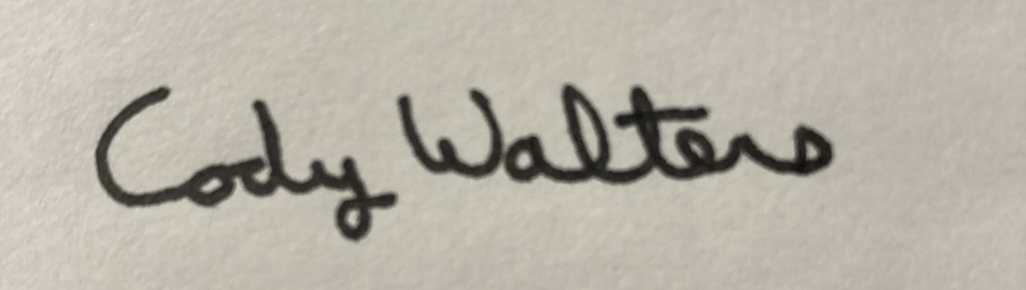 7/22/2025
________________________________________________________ _____________________
Cody Walters, Associate Procurement Specialist Date

