Request for Proposal #RFP-25-051
For
Digital Accessibility Consulting Project

Opening Date & Time: Wednesday, June 4, 2025 at 2:00 p.m.

Mandatory Requirements:

- Signed Cover Sheet
- Consultant Information Form
- Proprietary / Confidential Statement
- Exhibit 1 – Exception Form
- Exhibit 2 – Lobbying Certification
- Exhibit 3 – Non-Collusion Affidavit
- Exhibit 4 – Minimum Insurance Requirements
- Pricing Form
- Addendum(s) Acknowledged
- Completed W9

Consultant Name | Signed | Addendum (1) | Requirements Met
AccessAbility Officer | Yes | Yes | Yes
Accessible PDF Inc | Yes | No | No
Anthro-Tech, Inc. | Yes | Yes | Yes
Consultadd Inc | Yes | Yes | Yes
Converge Accessibility | Yes | Yes | Yes
CurbCutOS, Inc. | Yes | Yes | Yes
Infojini, Inc. | Yes | Yes | Yes
JAG Global Learning | Yes | Yes | Yes
Mandala Creative LLC | Yes | Yes | Yes
Mobikasa LLC | Yes | Yes | Yes
Nelnet Inc | Yes | Yes | Yes
Optimal Solutions Group | Yes | Yes | Yes
Perspective Tester, LLC | Yes | Yes | Yes
QualityLogic | Yes | Yes | Yes
Silhouette LLC | Yes | Yes | Yes
TaikaTranslations | Yes | Yes | Yes
YuJa Inc | Yes | Yes | Yes
Zenyth | Yes | Yes | Yes

Public Opening: Yes

Verified and Acknowledged for completeness and accuracy:

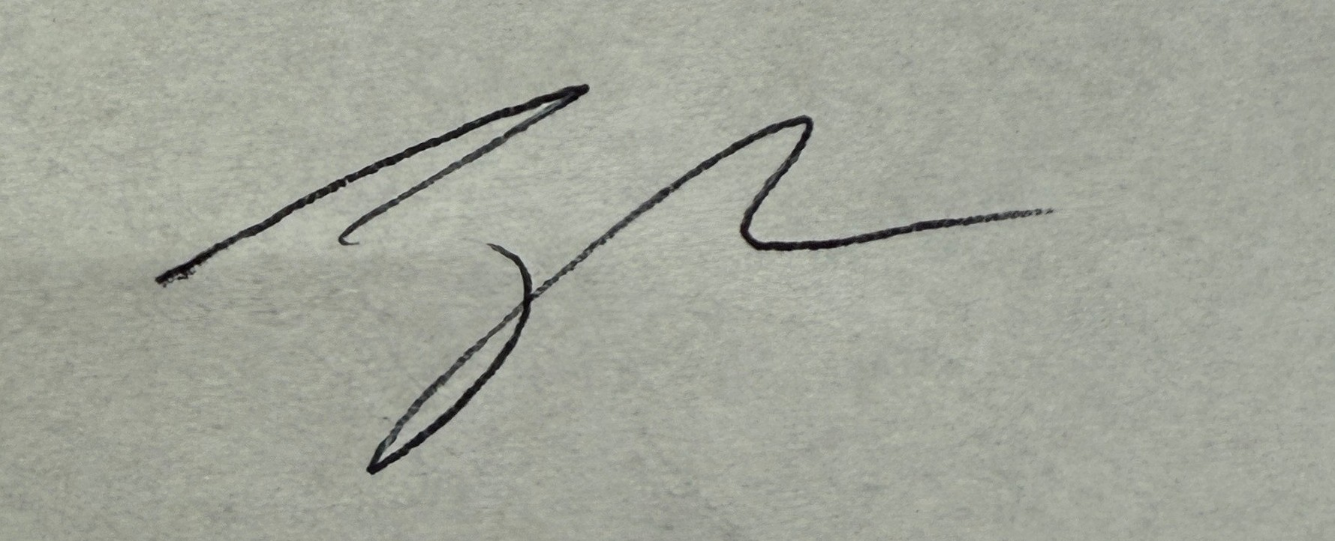

6/4/2025
Jake Harper, Associate Procurement Specialist Date
El Paso County, Colorado – Contracts and Procurement Division

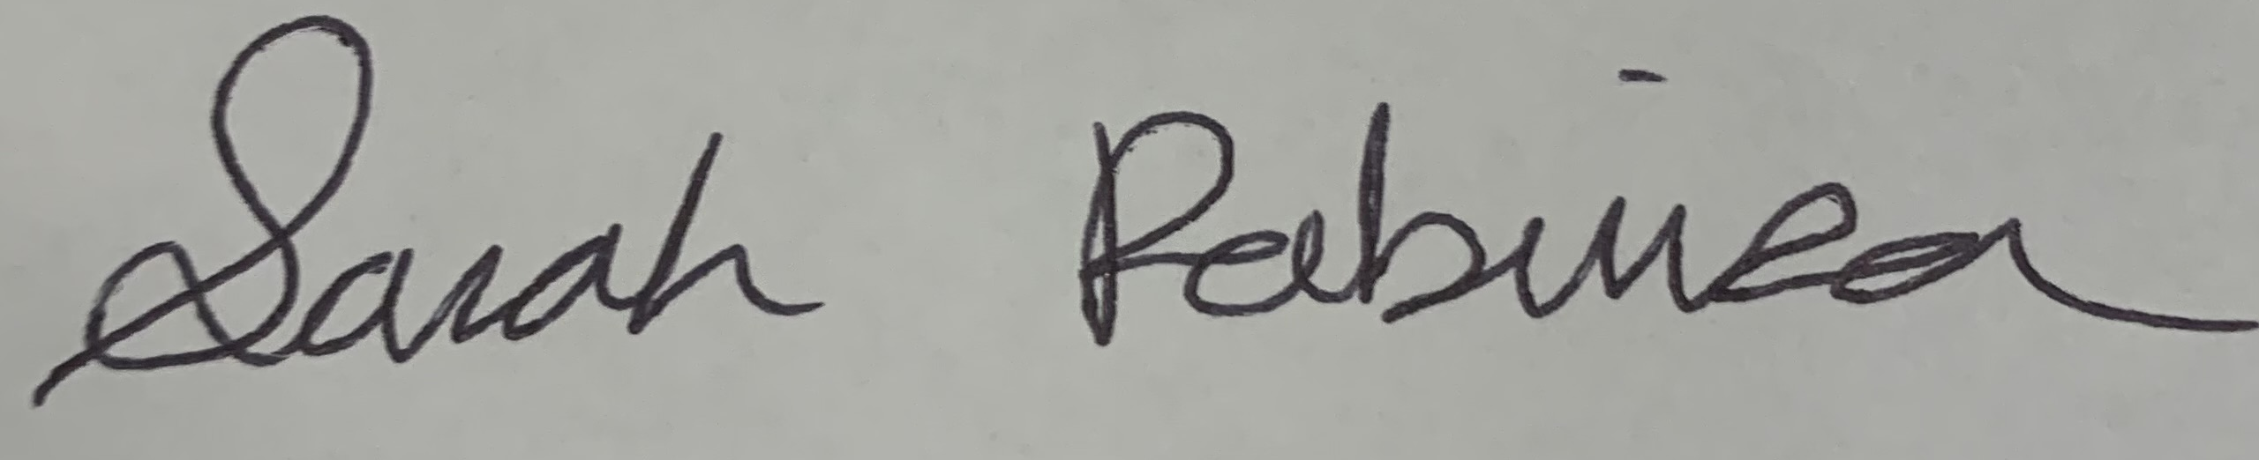
6/4/2025
Sarah Robinson, Administrative Coordinator Date
El Paso County, Colorado – Contracts and Procurement Division

