June 20, 2025

Alfred Benesch & Company
7979 E Tutts Avenue, Suite 800
Denver, CO 80237
Attn: Matt Salek, PE, Senior Project Manager
msalek@benesch.com

Dear Mr. Salek,

Thank you for your interest in providing El Paso County with services for the Woodmoor Drive and Lake Woodmoor Drive Intersection Improvements.

Based on El Paso County’s assessment of your submittal in response to our Request for Proposal, your firm has been selected to negotiate a contract with El Paso County, Colorado.

We will be in contact with your firm within the next few weeks to begin the process of negotiating a contract and the establishment of an operations plan for the Woodmoor Drive and Lake Woodmoor Drive Intersection Improvements.

In addition, you are requested to furnish within two (2) weeks of receipt of this letter, Certificates of Insurance evidencing compliance with El Paso County’s requirements for insurance and a copy of your current proof of registration with State of Colorado.

We appreciate your interest in doing business with El Paso County and encourage you to continue to apply for future opportunities.

Sincerely,

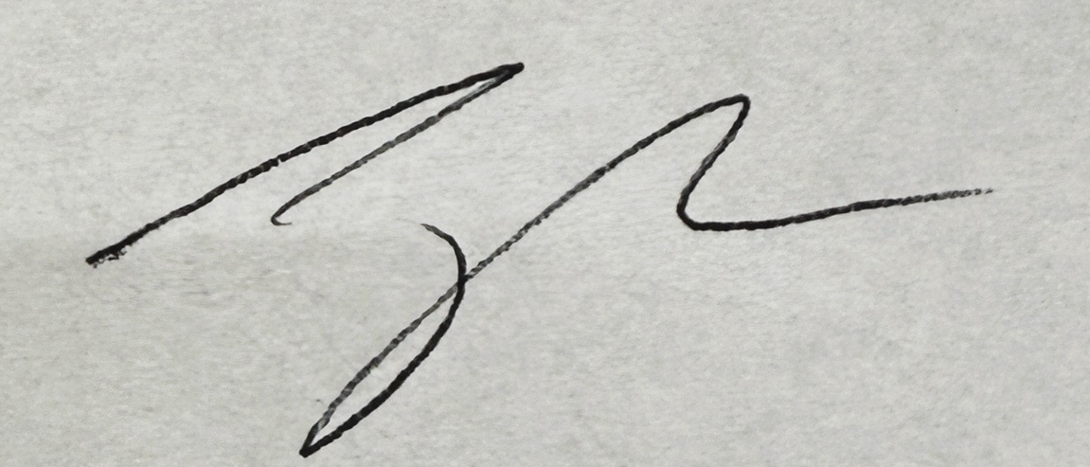

Jake Harper
Associate Procurement Specialist
JakeHarper@elpasoco.com
719-520-6857

