Request for Proposal #RFP-25-042
For
Citizens Service Center HVAC Controls Replacement

Opening Date & Time: Wednesday, June 11, 2025, at 2:00 p.m.

Mandatory Requirements:
- Signed Cover Sheet
- Respondent Information Form
- Proprietary/Confidential Statement
- Exhibit 1- Exceptions Form
- Exhibit 2- Lobbying Certificate
- Exhibit 3- Non-Collusion Affidavit
- Exhibit 4- Minimum Insurance Requirements
- Addendum 1, Addendum 2

Respondent Name | Signed | Addendum (2) | Requirements Met
Acco Brands USA LLC | No Bid | No Bid | No Bid
ACTS Electric, LLC | Yes | Yes | Yes
Air Comfort, Inc | Yes | Yes | Yes
American Mechanical Services of Colorado Springs | Yes | Yes | Yes
Colorado Controls | No | No | No
Lohmiller and Company | Yes | Yes | Yes
LONG Building Technologies | Yes | Yes | Yes

Public Opening: Yes

Verified and Acknowledged for completeness and accuracy:
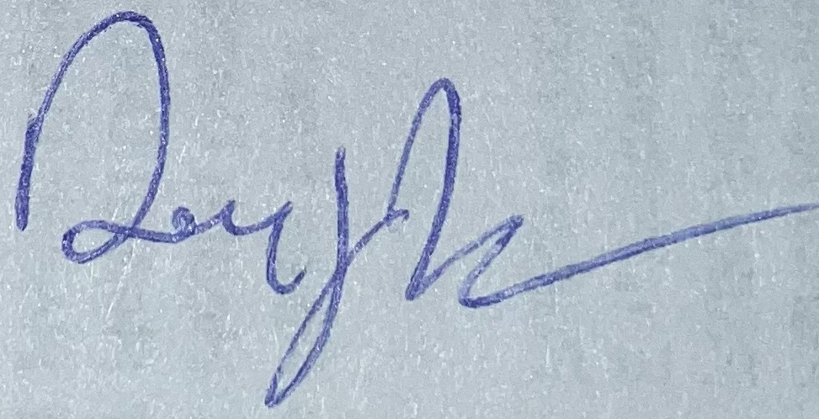 6/11/2025
Danny Tesh Associate Procurement Specialist Date
El Paso County, Colorado – Contracts and Procurement Division
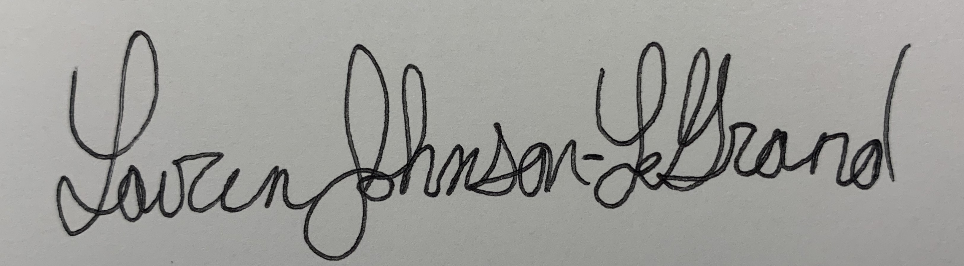 6/11/2025

Lauren Johnson-Legrand, Administrative Specialist Date
El Paso County, Colorado – Contracts and Procurement Division

