FINAL AWARD NOTIFICATION

RFQ-25-040
Paint Mines Interpretive Park Fencing

Term of Agreement: As of the date of the agreement (this is a workable working day contract, and shall be completed within 60 workable days)

Initial Contract Term: June 11, 2025 thru October 31, 2025

Piggyback Contract: No

PURCHASE BY OTHER GOVERNMENTAL AGENCIES: Each governmental unit which avails itself of this Solicitation will establish its own contact, place its own orders, issue its own purchase orders, be invoiced there from, and make its own payments and issue its own exemption certifications as required by the Vendor. It is understood and agreed that El Paso County is not a legally binding party to any contractual agreement made between any other governmental unit and the Vendor as a result of this Solicitation.

Awarded To: John Wayne Consulting dba Contract Euipment Operators
Ryan Hathorn, CEO & Director of Construction
PO Box 363
Mead, CO 80542
ryan@contractequipmentoperators.com
(720) 912-6725

Procurement Contact: Arron Bermea
Associate Procurement Specialist
arronbermea2@elpasoco.com
719-520-6489

Approved By:

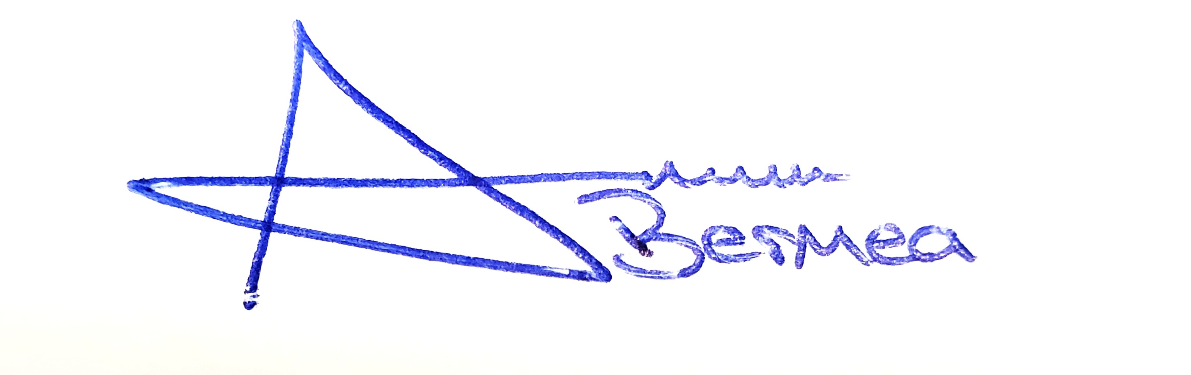
________________________________________________________ _____________________
Arron Bermea, Associate Procurement Specialist Date

