Request for Proposal #RFP-25-031
For
Professional Auditing Services

Opening Date & Time: Wednesday, June 25, 2025 at 2:00 p.m.

Mandatory Requirements:

- Signed Cover Sheet from this Solicitation
- Consultant Information Form
- Proprietary / Confidential Statement
- Submission Form
- Exhibit 1 – Exception Form
- Exhibit 2 – Lobbying Certification
- Exhibit 3 – Non-Collusion Affidavit
- Exhibit 4 – Minimum Insurance Requirements
- Addendum(s) Acknowledgement
- Project Plan
- Copies of requested Insurance Certificates (COI)
- Fee Proposal
- Certificate of Good Standing
- W-9 Documentation

Vendor Name | Signed | Addendums (2) | Requirements Met
CliftonLarsonAllen LLP | Yes | Yes | Yes
Eide Bailly LLP | Yes | Yes | Yes
RubinBrown | Yes | Yes | Yes

Public Opening: Yes

Verified and Acknowledged for completeness and accuracy:

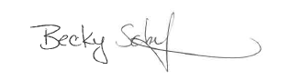
6/25/2025

Becky Schaffstein , Procurement Manager Date
El Paso County, Colorado – Contracts and Procurement Division

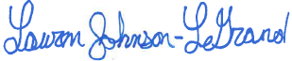 6/25/2025

Lauren Johnson-LeGrand, Administrative Specialist Date
El Paso County, Colorado – Contracts and Procurement Division

