FINAL AWARD NOTIFICATION

RFP-25-031
Professional Auditing Services

Term of Agreement: One-year with the option to renew for four additional one-year terms

Initial Contract Term: September 1, 2025 thru August 31, 2026

Piggyback Contract: No

PURCHASE BY OTHER GOVERNMENTAL AGENCIES: Each governmental unit which avails itself of this Solicitation will establish its own contact, place its own orders, issue its own purchase orders, be invoiced there from, and make its own payments and issue its own exemption certifications as required by the Vendor. It is understood and agreed that El Paso County is not a legally binding party to any contractual agreement made between any other governmental unit and the Vendor as a result of this Solicitation.

Awarded To: RubinBrown LLP
Ted Williamson, CPA
1900 16TH St. Suite 1700
Denver, CO 80202
ted.williamson@rubinbrown.com
314.678.3534

Procurement Contact: Arron Bermea
Associate Procurement Specialist
ArronBermea2@elpasoco.com
719-520-6489

Approved By:

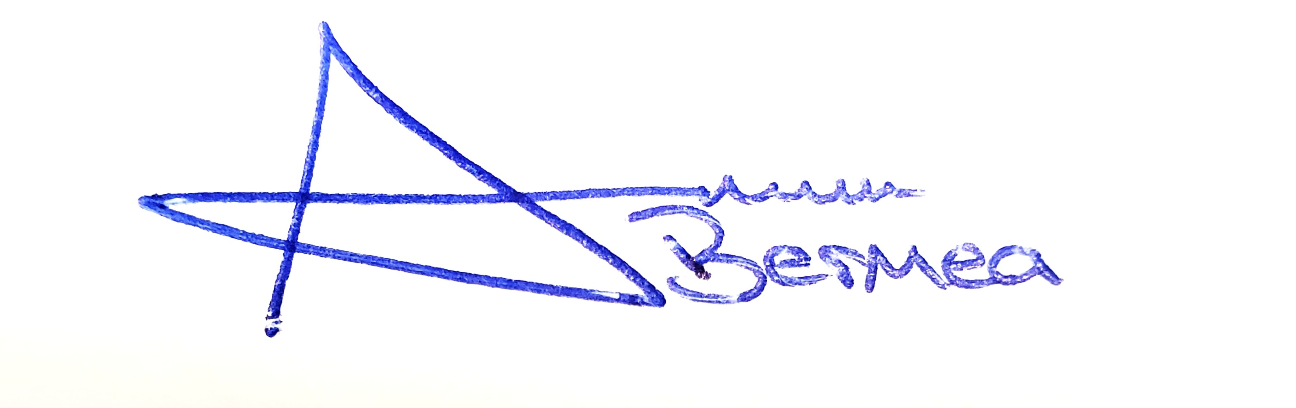
________________________________________________________ _____10/22/2025______
Arron Bermea, Associate Procurement Specialist Date

