# TRIMBLE UNITY CONSTRUCT PROJECT MANAGEMENT INFORMATION

## What is Trimble Unity Construct?

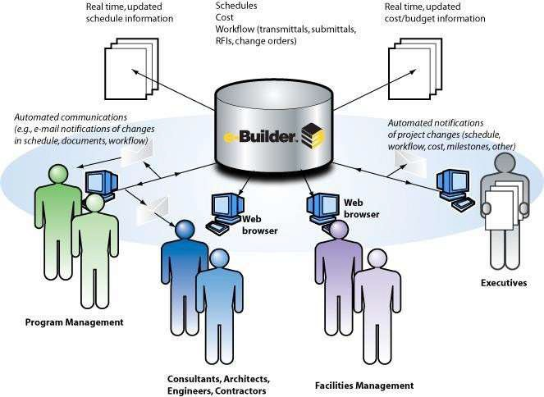Trimble Unity Construct is an Enterprise Construction Project Management System that helps owner organizations increase productivity, accountability, and profitability by providing easily accessible and real-time project data.

**eCntral Document Vault:** The Trimble Unity Construct system includes a central database that maintains all project information and manages project communications amongst team members.

**oCmmunication/Correspondence:** Trimble Unity Construct provides electronic routable communication forms that provide historical tracking, documentation, and increased accountability of project members.

# WHY IS EPC TRANSITIONING TO USING TRIMBLE UNITY CONSTRUCT?

Prior to using Trimble Unity Construct, El Paso County had many databases and paper files that information flowed into. Trimble Unity Construct has made El Paso County more efficient, consistent, and accountable when managing

construction projects through the use of Workflows, the Cost Module, Documents module, Reports, and general real-time Project Details.

# ELECTRONIC DATA REQUIREMENTS

Trimble Unity Construct is a cloud-based project management platform that can be accessed through any computer with a broadband internet connection. Performance of the platform is contingent on the Megabits per second (Mbps) of the available internet connection, with base hardware specifications as follows:

## Operating Systems:

* Windows 7 or later
* OSX v10.8 or later

## Supported Client Browsers:

* Microsoft Edge 91 or later
* Google Chrome 99 or later
* Mozilla Firefox 91 or later
* Safari 14 or later

## Recommended Software:

* Microsoft Office Suite (Microsoft Word, Excel, Outlook)
* Microsoft Project or Primavera

## Connection Speed/Minimum Bandwidth:

* DSL, ADSL, or T1 Line for transferring a minimum of 3 Mbps Download, 512 Kbps Upload

# TRIMBLE UNITY CONSTRUCT TERMS AND DEFINITIONS

Terms and definitions that may be utilized in the Standard Specifications or within these Project Special Provisions shall be interpreted to have different meanings within the scope of the Trimble Unity Construct platform. A summary of these redefinitions follows:

1. “CM” shall mean the Construction Manager designated by El Paso County
2. “Commitment” shall mean the Contracted amount with the vendor selected by El Paso County as shown on the Purchase Order.
3. “Contractor” shall refer and be synonymous to the selected Contractor, Consultant, and/or Vendor contracted with El Paso County.
4. “PM” shall mean the Project Manager representing El Paso County, Department of Public Works, which may also be known as the Project Engineer.
5. “Process” shall refer to the automated procedures built into the e-Builder platform. Processes follow a defined workflow utilizing a series of steps that require inputs or actions from all parties involved in the e-Builder Project. Certain permissions are associated with each process and step that may impact Contractor ability to initiate or act on specific processes.
6. “Workflow” shall refer to the programmed and/or graphic depiction of steps within a process.

# TRIMBLE UNITY CONSTRUCT STANDARD PROCESS DEFINITIONS

The Trimble Unity Construct platform utilizes Processes to initiate and control certain actions within the platform related to Project Management and Administration. Standard Processes within the platform are defined as follows:

**CMO:** Construction Modification Order

* + The Construction Modification Order process is for the Contractor(s) to review any proposed CMO and for the Project team to obtain approvals. If approved, the CMO process will automatically update the commitment with any changes.

**CPA:** Construction Pay Application (PayApp)

* + The Construction Pay Application process is for the Contractor(s) to submit their pay application/invoice for review by the Construction Manager and Inspector(s) and approval by the Project Manager.

**DQR:** Daily Quantity Report

* + The Daily Quantity Report process is for the Project Inspector(s) to submit their daily reports on the work performed, site conditions, and Contractor personnel at the Project site for the given day.

**PSA:** Professional Services Amendment

* + The Professional Services Amendment process is for the Project team to review and approve amendments to the Consultant’s commitment. If approved, the PSA process will automatically update the commitment with any changes.

**PSIP:** Professional Services Invoice Payment

* + The Professional Services Invoice Payment process is for the Consultant(s) to submit their invoice for review and approval by the Project Manager and Project team.

**RFI:** Request for Information

* + The Request for Information process is for the Contractor(s) and/or Construction Manager(s) to submit any questions on the Contract Documents and receive answers/responses from the Project team.

**SB:** Submittals

* + The Submittals process is for the Contractor(s) to upload any required or requested submittals to the Construction Manager and Project team for review and approval. All approved submittals will be automatically uploaded to the Project Documents within the platform with any comments.

# EXAMPLE TRIMBLE UNITY CONSTRUCT PROCESS

Processes in Trimble Unity Construct are designed to be simple, efficient, and intuitive. The process acts as a ball-in- court system where each step (rectangles) requires users to take action to push the process forward. There are different paths the process can take depending on certain information (diamond) and it can also send documents out (oval) to different email addresses or document folders within Trimble Unity Construct. At any point in the process both the Contractor and EPC actors will be able to view the current actor and the process progress.

The Construction PayApp (CPA) process depicted below for example manages Contractor or Consultant invoices. This process is initiated by the EPC Inspector and is identical for either Consultants or Contractors:

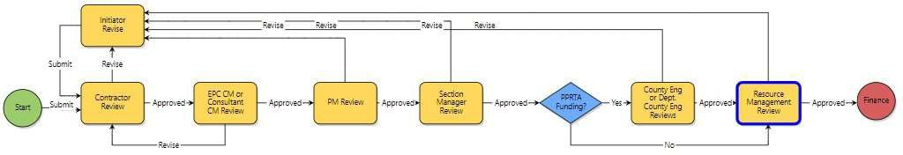

For the CPA process, the Contractor is an actor within Trimble Unity Construct who can submit invoices to the EPC inspector for review following the instructions on the screen below (at any time after submission, the contractor can click on “Current Actors” or “Show Workflow Diagram” to see the current status of their invoice):

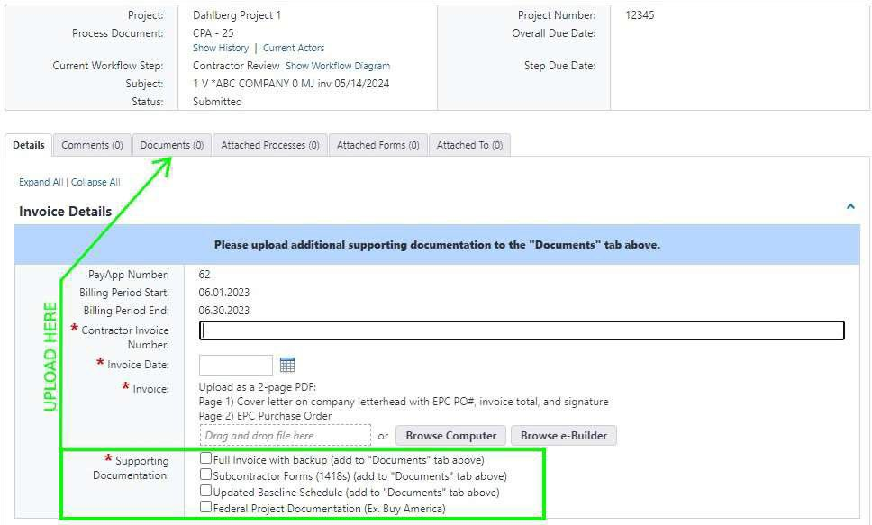

Upon review, the CM and any actors that follow can Approve or Revise with comments. If rejected, the initiator or applicant, can revise and resubmit their deliverable.

# CPA PROCESS PARTICIPANTS:

1. Inspector
2. Contractor/Consultant
3. CM (if project requires)
4. PM
5. Section Manager
6. County Engineer (PPRTA)
7. Resource Manager

# CPA PROCESS OVERVIEW:

1. After the submission of the invoice the process will route to the EPC CM or Consultant CM for review (if the project has one, otherwise the process will route to the PM).
2. The CM will approve the process to the PM Review step to continue approval. The PM can also send the process back to the initiator with a revise action leaving a comment to indicate the corrections needed upon completing the action execution.
3. The PM will approve the process to the Section Manager who will either approve the process directly to the Resource Manager or the County Engineer depending on whether the project is PPRTA funded.
4. The Resource Manager will approve the process through to Finance to process the invoice for payment

**REMAINDER OF PAGE LEFT INTENTIONALLY BLANK**